As mathematicians:
- Number and Place value
- Addition/subtraction
- Multiplication/division
- Mental maths
- Problem solving

As writers- Discussions
Books: ‘The Kapok Tree’ ‘Where the river meets the sea’
- Understand the job roles of David Attenborough and Steve Backshall.
- Journal written from the perspective of the Awa tribe.
- Begin to understand the different word classes.
- Understand the different sentence types.
- Recap different vocabulary, connective, opener and punctuation features.
- Write poetry using descriptive features.

Religious Education
- How Christians believe God looks after and provides for us.
- Harvest and symbolic stories.
- Jealousy and forgiveness.

Personal, Social, Health and Citizenship Education - New beginnings
- I can work well with others.
- I can recognise my own and others feelings.
- I understand the need for rules in school and wider society.
- I don’t give up but think how I can solve a problem.

Physical Education – Gymnastics/Rugby
- Use balances on different body parts to create bridges as individuals and with a partner.
- Practise and improve movements.
- Work cooperatively with a partner and create a sequence of moves.
- Vary level, direction and shape.
- Tag Rugby tactics
As designers and artists:
- Learn about the life and style of artist Henri Rousseau.
- Collect visual information to help develop ideas.
- Compare ideas and methods in their own and others’ work and say what they feel about them.
- Design, create and evaluate ‘living’ rainforests.
As scientists:
- Classify animals and plants.
- Revisit habitats and identify the different layers.
- Research the lifecycles of different animals.
- Identify the structure of flowering plants.
- Understand the different stages of a plants lifecycle – germination, pollination, seed dispersal.
- Understand how plants make their food.
- Identify how plants have adapted to survive in the rainforest.
South America – The Earth ship
Big Question: Are humans more important than rainforests?
Year 5 Term 1
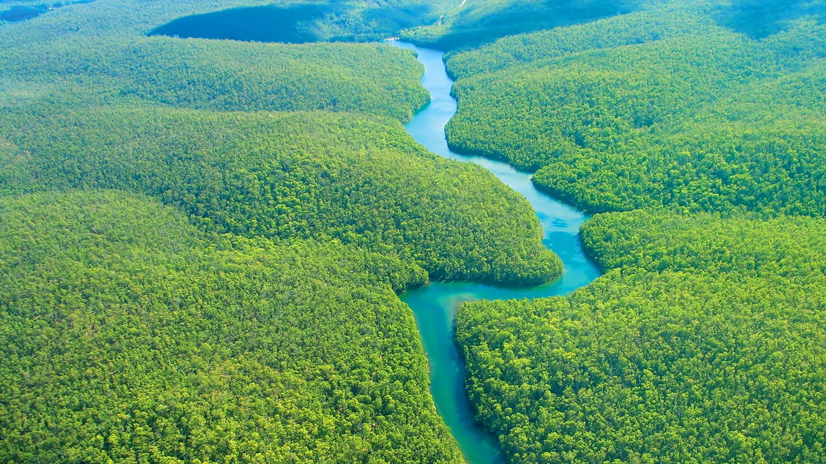

As computer experts:
- Use a variety of sources to research an area.
- Use google earth.
- Understand the importance of e-safety.
As readers:
- Use a range of sources to research an area or topic.
- Make key word notes.

As Geographers:
- Locate countries in South America.
- Identify physical and human characteristics of an area.
- Identify and describe different biomes.
- To consider the effects of human impact on an environment.
- Analyse information to draw conclusions.

