Literacy  Phonics: Phase 3 & 4  Stories & Poems based on the seaside or pirates Rainbowfish story  Information about the importance of water  Information about Rainforests  Information about Water safety  Write own poems  Make own books  Write a story about a Pirate | Foundation  Term 6 topic: Water  Possible Lines of Enquiry  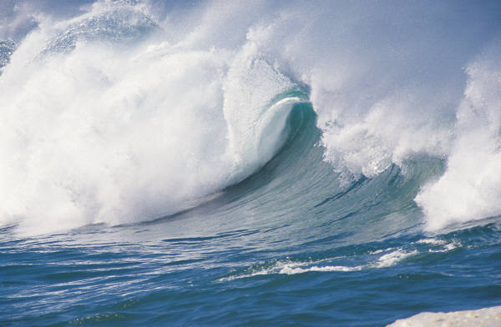 | Mathematics  Recognising and ordering 1-20  Addition and Subtraction  Sharing  Doubling  Halving  Problem solving  Separating groups of objects in different ways  Weight  Capacity  Naming and describing 2D and 3D shapes  Patterns  Position, direction and distance
Expressive Arts and Design  Pirate masks  Bubble Painting  Sand pictures & seaside art  Sea Creature paintings  Water creature clay models  Under the Sea/Weather Station role-play  Water/Seaside/ Pirate Songs  Creating music to represent water  Exploring tools & resources |  | Communication and Language  Listening to stories, nursery rhymes and songs  Circle Time & Snack time discussions  Using water – Vocabulary  Talk Time groups  Library group times  Respond appropriately to how and why questions  Role play areas, past  Present and future tenses
Physical Development  Fine motor skills  Letter/Number formation  Cutting  Large movements in dance  Use of outdoor large & small equipment  Sports Day.  Using equipment safely  Our bodies – exercise and keeping healthy  Summer salads/fruits  Growing cress/tomatoes  Staying safe in the sun | Understanding the World  ICT Skills - Develop skills to print & save work  Pilgrimages – why people travel & where to Water  Animals & Plants  Healthy Living  Sea creature models  Pirate Masks/models  Seaside models/boats. | Personal, Social & Emotional Development  Memories of Foundation  Transfer to Year 1  Water safety  Solving problems  Working together  SEAL – Getting on and Falling Out  Role play: Under the Sea and Weather Station
Characteristics of effective learning: finding out and exploring, playing with what they know, being willing to ‘have a go’, being involved and concentrating, keeping on trying, enjoying achieving what they set out to do, having their own ideas, making links, choosing ways to do things.

