Science: Digestive System and Teeth.

English:
Fiction: Myths and Legends
Non- Fiction: Plays
Homework: Set every Wednesday to be handed in the following Tuesday morning, English (20 mins) and Maths (20mins) are set weekly. In addition to set homework, children should spend 20 minutes reading 3 days a week.

Music: Recorder.

P.E: Wednesday: Gymnastics
Thursday: Rugby

Modern Foreign Language: French
Numeracy:
Multiplication and Division:
Recall multiplication and division facts for multiplication tables up to 12 × 12
Recognise and use factor pairs
Recognise multiplication as Arrays
Multiply two-digit and three-digit numbers by a one-digit number using formal written layout (Grid Method)
Use know multiplication facts to work out division facts
Recognise division as the inverse of multiplication
Recognise division as sharing and grouping
Divide numbers using formal written methods

PSHCE: Healthy Lifestyles 3: Me, my community and my environment.
SEALS: term 1New Beginnings. Getting on and Falling out.
.

R.E: Biblical Journey’s, the Christmas story.

ICT: Digital Media
The Roman Empire
Year 4, Term 2
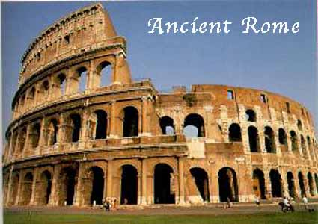
Topic: (History)
The Roman Empire and the impact on modern day Britain.
.

