Science: Changing States

English:
Fiction: Adventure Stories
Non- Fiction: Reports and Explanations
Homework: Set every Wednesday to be handed in the following Tuesday morning, English (20 mins) and Maths (20mins) are set weekly. In addition to set homework, children should spend 20 minutes reading 3 days a week.

Music: Recorder.

P.E: Wednesday: Paralympic Games
Thursday: Tag Rugby

ICT: To understand and use the term algorithm and debug and to use this knowledge to make a code.

PSHCE: Sensitive issues 1 &2: Growing up in a drug using world and Keeping Myself safe.

R.E: New Year
The importance of Jewish synagogue/Shabbat and Jewish Rabbi

Numeracy:
Decimals:
Understand the meaning of a decimal number
Understand the value of different decimal numbers
Round decimal number to the nearest whole number
Order decimal numbers
Add and subtract decimal numbers
Measures:
Choose and use standard metric units and their abbreviations when estimating, measuring and recording length, weight and capacity.
Interpret intervals and divisions on partially numbered scales and record readings accurately, where appropriate to the nearest tenth of a unit

Modern Foreign Language: French
Volcanoes and Earthquakes
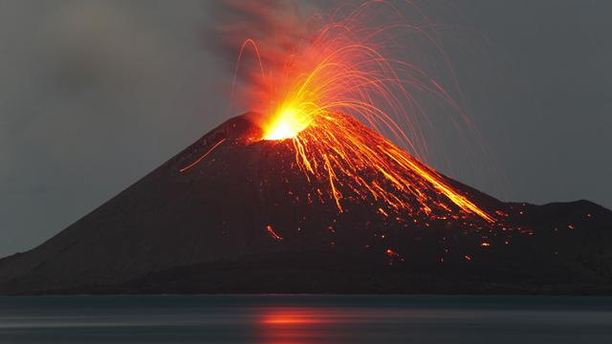
Year 4, Term 3
Topic: (Geography) Volcanoes and Earthquakes.
- To know the meaning and understand the terminology related to Volcanoes and Earthquakes.
- To Understand the structure of the earth/volcanoes
- To understand plate tectonics
- To understand how and why volcanoes and earthquakes occur

Art/D.T: Tudor Rose, Tudor Houses, Tudor Clothing

