STOCKHAM PRIMARY SCHOOL
THURSDAY NEWSLETTER

Issue No: 490 Thursday 11th October 2018
Dear Parents,
Thank you to all the families that brought in their clothes bags for school. The FOS send their thanks and will let you know how much money the bags have made. We look forward to seeing you at the Halloween disco this Friday. Please ensure that children are dressed up in a spooky way… but not too scary, we do not want younger children to be frightened.
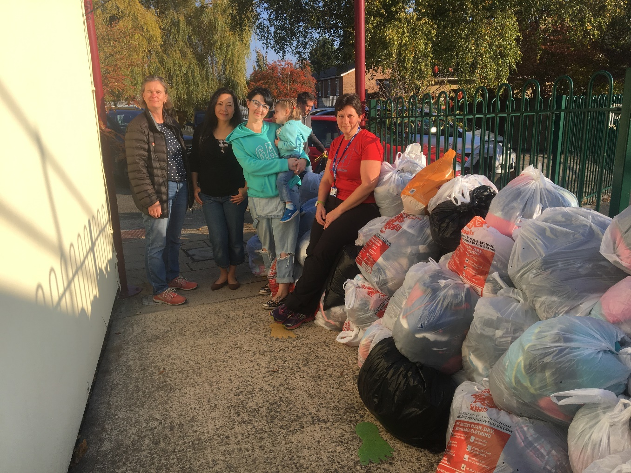

Coming up soon…
Friday 12th October – School photo day, Friends of Stockham Halloween disco at 6.30pm.
Monday 15th and Tuesday 16th October –Parents Teacher meetings. Year 4 PTIs will take place on 16th and 18th October.
Friday 19th October 3.05pm –School ends for the October half term.
Monday 29th and Tuesday 30th October –INSET days – children not in school on these two days.
Wednesday 31st October – Children return to school at 8.40am
6th November – Open Evening for parents and children. This year’s focus is on Mental Health and Well-being. We will be exploring the broader curriculum and how our topic based approach to learning can help support mental health. Some of the things you can look forward to during the evening are:

- Hearing the whole school sing
- Visiting all the classrooms and taking part in activities linked to well-being and the broader curriculum
- A school quiz hunt
- A pupil led piano concert
- Watch or join in with a mindfulness session/yoga
- Toast a marshmallow and build a den in our forest school
- Explore all the emotional support resources and meet the staff who deliver all our wonderful interventions
- Enjoy a taster meal from our school kitchen
Please look out for an Open Evening flyer coming home at the start of next term.
2nd November– Mental Health awareness day – children wear non-school uniform (bright colours)
Lunchtime Supervisor vacancy
We are currently looking to appoint a lunchtime supervisor, starting as soon as possible. This position is for 7.5 hours a week. Please let me know if you are interested in this position and would like a copy of the job description and person spec. The successful candidate must be committed to following the school’s safeguarding and behaviour policies.
Many thanks,
Mrs. Burbank

PA’s this week were Lewis and Riven. Thank you for your help.

CLASS NEWS

Year F This week we have been making autumn collages. The children enjoyed using
leaves and twigs to create their own autumn scene. In phonics we have learnt a
new sound, p. The children have started to read short words using all our sounds
we have learnt so far.
Year 1 In maths we have been looking at adding one more to numbers 0-9. In English we
have started to think about non-fiction facts about meerkats.
Year 2 We have been adding by counting on in maths this week. We have used pictures and
number lines to do this. We had an exciting visitor from Rutherford to complete a
wonderful space workshop with us! We loved all the exciting activities he shared with
us!
Year 3 In Year 3 we have been adding multiples of 100 in maths and we have investigated
magnetic poles in science. We also got very messy using charcoal in art!
Year 4 In English this week Year 4 have been learning how to improve their writing using a
range of adverbs. In geography we have been learning about the features of
estuaries and in our music lesson we mastered how to play ‘A’ on the recorder!
Year 5 We have been looking at addition in maths and we have looked at deforestation in
topic and written newspaper reports.
Year 6 Year 6 have been exploring punctuation types. In maths we have been revisiting
division. We have been planning and researching our Morrison shelters in DT.

Soaring High
This week the following children have earned “Soaring High”:
Year F This week Kacie has made all the adults smile. She has tried her best
during all lessons and has done some amazing tidying up! Elijah G for his
fantastic work during phonics. Elijah is always ready to learn and is eager to
participate during the lesson.
Year 1 Annabelle and Isabella for always using all of their learning powers and taking
part fully in everything we do in Year 1. Well done girls!
Year 2 Spencer for joining Year 2 with such confidence, independence and
determination. You have settled into Stockham so wonderfully well! Eva for
showing the confidence and perseverance to try a ‘dive’ activity in maths. You
could do it! Well done!
Year 3 Milly and Jennifer for having the confidence to complete their maths work
independently! Well done girls!
Year 4 Georgia for some great descriptive work in English. Hallie for some good work
when describing changes in state in science.
Year 5 Lucy M for using her confidence in swimming – Well done! Faith for
understanding the two sides of deforestation!
Year 6 Rory for always persevering with his learning and sharing his ideas in lessons.
Lillie P for trying really hard at multiplication and division in maths.

Well done everyone!

On Wednesday 17th October, football Paralympian Alistair Patrick- Heselton will be visiting to hold an assembly for the children and take part in a fitness circuit with them to raise money for the charity and school. Thank you to everyone who has been busy collecting sponsorship money for this event! Last year, this was very inspirational for the children and I am sure it will be the same again this year.

Tidy Tiger
This week Tidy Tiger goes to Year 2 for having the tidiest room. Well done!

Attendance Ted
Attendance Ted was awarded to Year 6 for having the best attendance last week, they will be looking after Attendance Ted next week. Well done Year 6!

School Uniform
If you need new uniform please order online or by telephone. The website is pmgschoolwear.co.uk and the order line is 0800 4046644.
Book bags and PE bags are also available to be purchased from pmgschoolwear.

