English:
Fiction –Narrative and Performance Poetry
Non-Fiction – Letters to local residents linked to Geography work.
SPAG (Spelling, Punctuation and Grammar) –use of conjunctions, adverbs and prepositions. Spell words using prefixes and suffixes. Spell homophones.

Science: Habitats
Identify changes to environments
Describe how some animals adapt to their environment.
Describe what climate change is
Plan a change to a local area.

Modern Foreign Language: French – Numbers 13-31

Music: Recorder and singing.

Art: Landscapes and local sketches

P.E: Rounders and Athletics.

R.E: What festivals and celebrations are important?

Focus on Judaism.

PSHCE: SEAL Changes
And Growth Mindset

Maths:

Statistics:
Interpret and present data using appropriate graphical methods, including bar charts and time graphs.

Solve comparison, sum and difference problems using information presented in bar charts, pictograms, tables and other graphs.

Measurement:
Convert between different units of measure
Measure and calculate the perimeter of a rectilinear figure (including squares) in centimetres and metres.

Find the area of rectilinear shapes by counting squares.

Revision and Assessment

How and why is our local area changing?
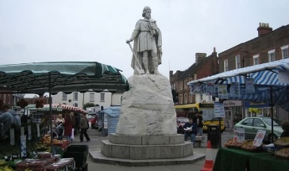
Year 4, Term 6
Topic: (Geography). How and why is our local area changing?

Explain why some environments change.
Find out about changes to our school
Create a way of judging the quality of our local area
Carry out fieldwork gathering data about our local area
Test a hypothesis about our local area.
Homework: Set every Wednesday to be handed in the following Tuesday morning, English (20 mins) and Maths (20mins) are set weekly. In addition to set homework, children should spend 20 minutes reading 3 days a week. They will then be entered into our weekly Reading raffle!

Art/D.T: Tudor Rose, Tudor Houses, Tudor Clothing

