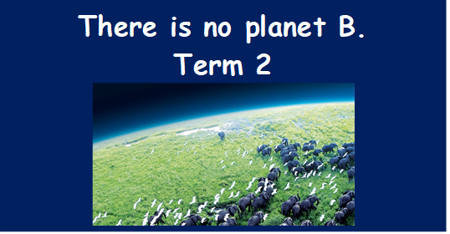
As writers:  Write simple descriptions.  Use dialogue to create and advance action.  Explore characterisation.  Use a variety of techniques to develop sentences for detail and effect.  Plan, draft, edit and improve.  Class Read: Floodlands.  Narrative: ‘Walle’  Non fiction: Persuasive messages  Poetry: The river.  S&L: Discussion: COP26. Climate protests – “Sometimes you need to anger people” Greta Thunberg. Do you agree or disagree? |  | As Athletes:  Tag Rugby  To carry, send and receive a rugby ball effectively.  To defend and attack tactically by anticipating the direction of play.  To lead others when called upon. To be a good role model to others.  To apply skills to a game situation  Dance  Combine movements effectively  Perform with purpose | As design technologists:  Gain practical experience to reinforce their learning around forces and electricity.  Develop problem-solving, team working and presentation skills. Discover how STEM can help solve global issues and achieve the UN Global Goals.  Engage in scientific enquiries that explore the impact and efficiency of recycling.  Learn about the impact of plastic waste in the UK and globally.  Investigate how bioplastics are made.  Design and make a marketable product from waste plastic. | As scientists:  Evolution and inheritance:  Recognise that living things have changed over time and that fossils provide information about living things that inhabited the Earth millions of years ago.  Recognise that living things produce offspring of the same kind, but normally offspring vary and are not identical to their parents.  Learn about important people and theories helping to shape scientific ideas.  Understand how science can support or refute ideas.  Research human evolution.  Identify how plants and animals are suited to their environment and understand how adaptations can be beneficial or not.
As readers:  Inference practice.  Using ‘point, evidence and explain techniques’  Predict  summarise.  Explore ‘genre’ |  | As Mathematicians:  Place value  4 operations – introduction of long division  Number – decimals  Statistics  Measurement | As linguists:  Days of the week  Hobbies – je vais  Moths of the year  Numbers to 50 | As musicians:  Christmas performance  Sia and Hanz Zimmer – the power of words  Storm – Peter Grimes - graphic score
As computer Experts:  E-safety and information reliability.  Researching and compiling information |  | As Geographers:  Collect and analyse statistics to draw clear conclusions  Identify and describe the significance of geographical lines  Describe how geographical locations are changing and explain some reasons for the change  Describe how countries and geographical regions are connected  Describe and understand some key aspects of physical geography (climate, biomes) and human geography (land use, economic activity, distribution of natural resources) | Religious Education:  How is Christian worship expressed?  How can I communicate what inspires me & influences me?  To know that Christians can use music and art to express their beliefs, feelings and values.  To know that different cultures & traditions may worship God in different ways. | As citizens:  I understand there are different perceptions about what normal means.  I understand how being different could affect someone’s life.  I can explain some of the ways in which one person or a group can have power over another.  I know some of the reasons why people use bullying behaviours.  I can give examples of people with disabilities who lead amazing lives.  I can explain ways in which difference can be a source of conflict and a cause for celebration.
Key Vocabulary: | Fossils, classifying, inheritance, variation, adaptation, evolution, dominant, recessive.  Fossil fuels, deforestation, extinction, emissions, sustainability, renewables, conservation, climate zones, natural resources, biomes, recycle, gyres, pollution  Diversity, permafrost, ecosystems, nature.

Curriculum Drivers: | Curiosity: | Knowledge of the wider world: | Aspirations:
 | Exploring climate change.  Why does climate change matter to me?  How is our planet changing?  How can we make it better?  What is COP26? | Understanding the term ‘climate change’ and how it is changing the world around us.  Exploring the fragile beauty of our planet.  Exploration of the lives of others – particularly children – and the effects of climate change on them.  The positive actions being put into place to combat climate change. | How could you change the world for the better?  Introduction of STEM opportunities.  Introduction of inspirational young people making a difference to the world.  Exploring climate change achievements of the past.  The power of children’s voices.  Writing to the local MP.

