Mathematics
- Difference
- Multiplication
- Division
- Problem solving
English
- Pirate Poems
- Dictionaries
- Phonics
- Guided Reading
- Comprehension Tasks
Religious Education:
- Why is the church an important place for Christians?
PSHCE:

- Relationships and Bullying

Physical Education:
- Running
- Jumping
- Throwing
- Aiming
- Athletics
Pirates Ahoy!
Year 1 Term 5
Mrs K Mascord
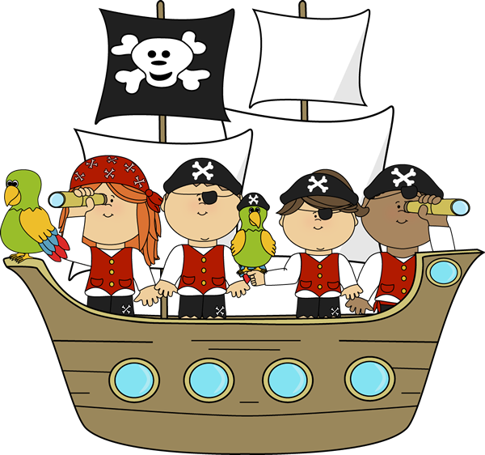
Computing
- Algorithms and Programs (Beebots)

Art & Design/Design & Technology
- Design, make, evaluate and improve
- Pirate Ships
- Painting
- Pirate island & ship wall display

Science
- Plants

Music
- Songs about pirates
- Exploring instruments & symbols

Geography
- Use simple compass directions and locational/directional language
- Pirate maps and treasure

