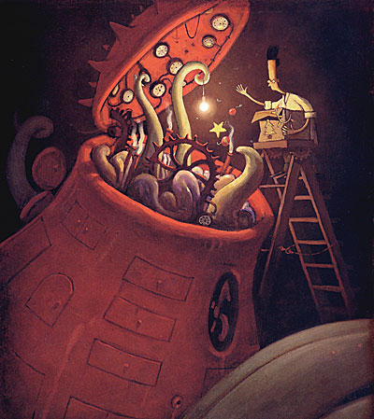
Shaun’s diary entry
Imagine you are Shaun and you have just got to the end of the first day with The Lost Thing – you have just fed it all those amazing things. Write a diary entry explaining all about your day and how you feel about it.

________________________________________________________

________________________________________________________

________________________________________________________

________________________________________________________

________________________________________________________

________________________________________________________

________________________________________________________

________________________________________________________

________________________________________________________

