Last week Mrs West, known as the Wicked Witch of the West, attacked an innocent young girl taking a trip along the yellow brick road with her friends.

Mrs West, of The Dark Castle on the outskirts of the town of Oz, is currently unemployed but she spends her spare time searching for humans to ‘tear them to shreds’.

When our reporter interviewed Mrs West yesterday she said she would continue to seek out humans to kill. “I’m feeling ready to hit again. That young Dorothy may have stopped me this time but she will not do so again!”

“The whole thing happened last week. I saw this little girl walking along the yellow brick road with a scarecrow, a lion and a tinman. I could see they were coming towards my castle. Strangers are not welcome here!”

“I sent my servants of wolves, crows and bees to stop them but they were too powerful and they defeated my devoted helpers.”

Visibly frightened, Mrs West continued, “They reached my castle and I could see that the little brat was wearing the magical silver slippers! I had to have them!

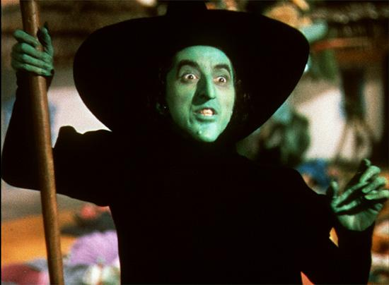

She continued “My plan was going swimmingly too, until Dorothy discovered my powerlessness against water. I was defeated. But I will return!”

Police say the witch has been warned to stay away from the young girl and her friends. She has been officially cautioned.

Mrs West however showed no remorse and rudely stated, “I’m feeling better now, I am healing well, and I’ll soon be hunting for humans again.”

Let’s hope the police are watching her very closely.

By K Mascord

