04/09,25/09,16/10,13/11,04/12,08/01,29/01  Ham & Cheese pasta bake On the side:  Pasta in a tomato sauce with Garden Peas  diced ham and a cheese topping Fresh Carrots  Vegetable pasta bake (v) For Dessert:  Pasta in a tomato and vegetable sauce Chocolate shortbread | 11/09,02/10,30/10,20/11,11/12,15/01,05/01  m  Deep pan margherita pizza On the side:  Homemade deep pan cheese & tomato Peas  Pizza with potato wedges Baked Beans  Cheese Omelette (v) For Dessert:  Fresh Fruit Salad  Crème Fraiche | 18/09,09/10,06/11,27/11,01/01,22/1  Macaroni Cheese On the side:  Shortcut macaroni in a Garlic Bread  Creamy cheese sauce Broccoli & carrots  Tomato and pasta bake(v) For Dessert:  Shortbread
Butchers Bangers & Mash On the side:  Butchers pork sausages served Baked Beans  With creamy mashed potato Sweetcorn  Quorn Sausages (V) For Dessert:  Fruity crumble  Custard | Spaghetti Bolognese On the side:  Beef Bolognese sauce served with Broccoli  Spaghetti Garlic Bread  Quorn Bolognese (v) For Dessert:  Carrot Cake | Butchers classic Beef burger in a bun On the side:  Handmade beef burger in a bun with Sweetcorn  Tomato sauce Coleslaw  Served Potato wedges  Vegeburger in a bun(v) For Dessert:  Ginger cake
Roast Chicken On the side:  Roasted Breast of chicken served Broccoli  With crispy potatoes, stuffing, Green Beans  Yorkshire pudding & gravy  Cauliflower Cheese Bake(V) For Dessert:  Jam & Coconut  Sponge | Roast Turkey On the side:  Roasted Breast of turkey served Carrots  With crispy potatoes, stuffing, Cabbage  Yorkshire pudding & gravy  Quorn Sausages (V) For Dessert:  Fruity Flapjack | Roast Pork On the side:  Roast pork served Peas  With crispy potatoes, , Carrots  Yorkshire pudding & gravy  Golden Quorn fillet(V) For Dessert:  Iced orange lemon  sponge
Spaghetti & Meatballs On the side:  Popular meatballs in a tomato sauce Sweetcorn  Served with spaghetti Carrots  Quorn meatballs(V) For Dessert:  Dinky Dino Cheese  Crackers & Grapes | 100% Chicken nuggets On the side:  Farm assured chicken nuggets Coleslaw  Herby diced potatoes Sweetcorn  Vegetable Nuggets (V) For Dessert:  Chocolate &  Banana Cake | Ham & Pineapple Deep Pan Pizza On the side:  Homemade deep pan pizza served with Fresh mixed salad  Herby diced potato  Cheese & Tomato Deep pan pizza (V) For Dessert:  Fruit Crumble  Custard
Jumbo Fish finger & Chips On the Side:  Jumbo fish fingers coated in Baked Beans  Breadcrumbs served with chips Garden Peas  Crispy Crumb Vegetable burger (V) For Dessert:  Combination of potatoes, sweetcorn, Chocolate brownie  Carrots and peas in breadcrumbs Crème fraiche  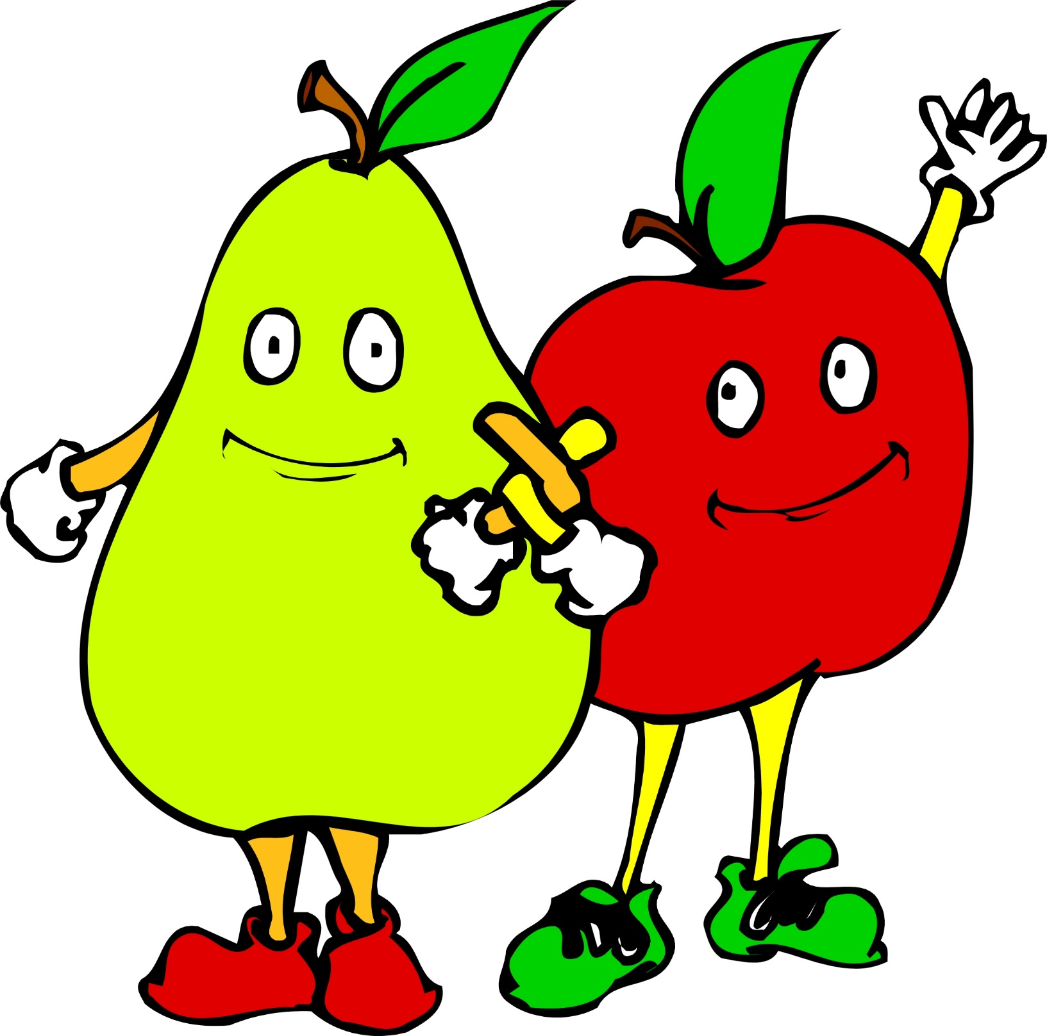 Fruit & yoghurts available daily | Fishwich in a bun & chips On the Side:  White fish fillets portions in breadcrumbs Baked Beans  Served in a bun with chips Garden Peas  Vegeburger in a roll (V) For Dessert:  Vanilla Ice-cream  Jelly  Jacket Potatoes with various fillings  Available daily | Breaded Pollock fillet & chips On the Side:  Alaskan Pollock fish coated in Baked Beans  breadcrumbs Garden Peas  Quorn Sausages (V) For Dessert:  Fruit Jelly  Vanilla Ice-cream  Wholemeal Bread available daily  Fresh salads prepared daily

