English  - Form letters correctly  - Sequence sentences  - Join ideas using ‘and’  - Use full stops, capital letters and finger spaces  - Spell words correctly  - Re-read and discuss our writing in order to improve it  - Listen to and discuss a range of stories and poems  - Retell a familiar story  - Develop vocabulary  - Use phonic knowledge to decode words when reading.  - Re-read books to build up fluency  - Correct inaccuracies when reading | Year 1  Term 6  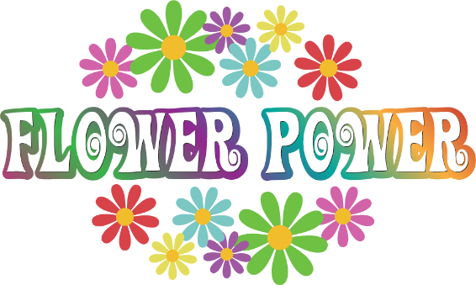 | Maths  - Count forwards and backwards to 100  - Write and recognise numbers to 100  - Count in 2s, 5s and 10s  - 1 more and 1 less  - Addition and subtraction  - Multiplication and division  - Halves and quarters  - Recognise and know the value of different coins and notes  - Measure and begin to record lengths/ heights/ mass/ weight/ capacity/ volume/ time.  - Days of the week and months of the year  - 2D and 3D shapes  - Position, direction, movement and turns
Science - Plants  - identify and name a variety of common wild and garden plants, including deciduous and evergreen trees  - identify and describe the basic structure of a variety of common flowering plants, including trees | Art  - Charles Rennie Mackintosh | Geography  - Fieldwork in the local area
 | PE  - Athletics and team games | DT  - Healthy eating  - Where does food come from?
PSHE – Change  - Things about me which will change.  - Changes which are natural  - Changes which are quick or which take a long time.  - Changes which I can make. | Computing  - De-bug code  - Organise, store, retrieve and manipulate data | RE  - What do Muslims believe about God?  - Why is God important for Muslims?  - What do I find interesting or puzzling about these ideas?

Please continue to read with your child as much as possible (at least 3 times a week, please sign or comment in their Reading Journal) and encourage them to use the Mathletics website at home. Reading books will be changed by a member of staff once a week; please support your child as they re-read their books several times as this will help develop their fluency and expression.

As ever, your child will also need their book bag (with Reading Journal), water bottle, plimsolls and
PE kit (including trainers) in school every day (all items clearly named, please!) PE kit consists of a white t-shirt and black shorts. Leggings or jogging bottoms may also be included in case of cold
weather, and your child will need a plain t-shirt in their house colour for Sports Day and other events. Please note it is essential your child has a pair of trainers in school for outdoor PE lessons this term.

Thank you to all those parents who are supporting their children coming into the cloakroom
independently in the mornings, this is very important as the children prepare for Year 2. Monday mornings will continue to be parent’s mornings when you are welcome to accompany your child into the classroom at the start of the day until registration.

Please come along to our class assembly at
2:40pm on Tuesday 19th June!

Living Rainforest Trip Monday 2nd July
(payment due by Monday 11th June, thank you.)

Homework projects are due in on Monday 9th July.

Thank you for your continued support, please do not hesitate to contact me if there is any further information you require.

Mrs Sarah McNaught

Please continue to read with your child at home as much as possible (at least 3 times
a week) and record this in their Reading Journal.

End of Year 1 Reading Expectations:

Decode words by:

- Using phonic knowledge to segment and blend sounds
- Recognising ‘tricky words’ which cannot be sounded out
- Read words ending in –s, -es, -ing, -ed, -er and
-est
- Reading words of more than one syllable
- Reading contractions such as I’m, I’ll and we’ll
- Re-reading books to develop fluency

Show I understand what I read by:

- Listening to and discussing a wide range of
poems, stories and non-fiction at a level
beyond that at which I can read
independently
- Linking what I read to my own experiences
- Becoming familiar with a range of traditional
tales and fairy stories, and being able to re-tell them
- Recognising and joining in with predictable
phrases
- Knowing some rhymes and poems by heart
- Talking about new words
- Checking what I am reading makes sense
- Predicting what might happen next in a
story
- Making inferences on the basis of what is
said or done in a story

