Shape | Name of Shape | Number of Faces | Face Shapes | Curved or flat faces? | Can it roll? | Can it stack?
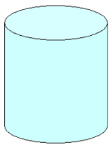 | Cylinder | 3 | Circle | 2 flat  1 curved | Yes | Yes
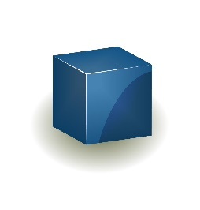
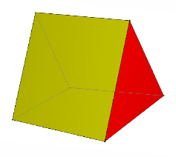
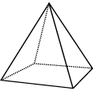
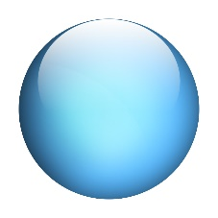

What do you notice?
3D Shapes with ………………………………………………… faces can always ……………………………………………….

3D Shapes with ……………………………………………….. faces can always …………………………………………………

3D Shapes with both …………………………………………….. and ………………………………………. faces can
……………………………………………………… and …………………………………………………….

