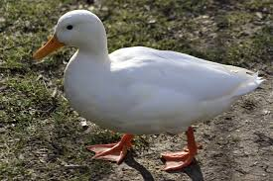
Farmer Duck Week 1
Farmer Duck had to do all the work around the house and farm. The lazy farmer stayed in his bed all day. He ate chocolates, read his favourite newspaper and he never cleaned up his mess. Poor duck! He even had to wash the farmer’s dirty clothes.
The duck had to fetch the cows, fetch the sheep and put the hens in their house. The duck just answered, “Quack!” when the farmer asked how the work was going.

Farmer Duck Week 1
Farmer Duck had to do all the work around the house and farm. The lazy farmer stayed in his bed all day. He ate chocolates, read his favourite newspaper and he never cleaned up his mess. Poor duck! He even had to wash the farmer’s dirty clothes.
The duck had to fetch the cows, fetch the sheep and put the hens in their house. The duck just answered, “Quack!” when the farmer asked how the work was going.

Farmer Duck Week 1
Farmer Duck had to do all the work around the house and farm. The lazy farmer stayed in his bed all day. He ate chocolates, read his favourite newspaper and he never cleaned up his mess. Poor duck! He even had to wash the farmer’s dirty clothes.
The duck had to fetch the cows, fetch the sheep and put the hens in their house. The duck just answered, “Quack!” when the farmer asked how the work was going.

