Learning Goals: I can infer information in the text. I can put sentences in order.  sawed, weepy, comforted, cunning | Independent Paired work  Group work Supported  Verbal Feedback
Fiction – Farmer Duck –Week 2
- How do you know that the other animals felt sorry for Farmer Duck?
- Write out the jobs in the order that Farmer Duck did them.

Farmer Duck sawed the wood.
Farmer Duck washed the dishes.
Farmer Duck picked the apples.
Farmer Duck washed the clothes.
Farmer Duck dug the garden.
Extension choice 1 - Use the new vocabulary in sentences of your own.
Extension choice 2 – Draw a picture and add a sentence to say what you think will happen next.

Scaffolding for Silver
Learning Goals: I can infer information in the text. I can put sentences in order.  sawed, weepy, comforted, cunning | Independent Paired work  Group work Supported  Verbal Feedback
Fiction – Farmer Duck –Week 2
- How do you know that the other animals felt sorry for Farmer Duck?

I know that the other animals felt sorry for Farmer Duck because

_________________________________________________________ .

- Write out the jobs in the order that the Farmer Duck did them.

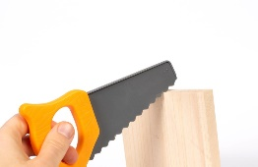  Farmer Duck sawed the wood. | 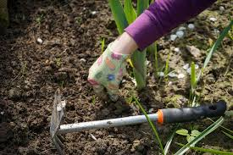  Farmer Duck dug the garden.
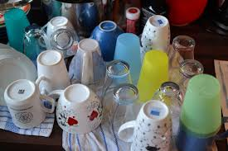  Farmer Duck washed the dishes. | 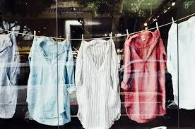  Farmer Duck washed the clothes.
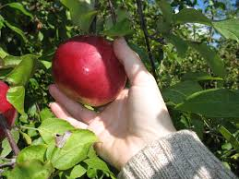
Farmer Duck picked the apples.

Extension choice 1 - Use the new vocabulary in sentences of your own.
Extension choice 2 – Draw a picture and add a sentence to say what you think will happen next.

Scaffolding for Bronze
Learning Goals: I can infer information in the text. I can put sentences in order.  sawed, weepy, comforted, cunning | Independent Paired work  Group work Supported  Verbal Feedback
Fiction – Farmer Duck –Week 2
- How do you know that the other animals felt sorry for Farmer Duck?

I know that the other animals felt sorry for Farmer Duck because

they were mean to him. | they were kind to him. | they were nasty to him. | they ran away from him.
- Cut out and put the jobs in the order that Farmer Duck did them.

The duck sawed the wood. |  | The duck dug the garden.
The duck washed the dishes. |  | The duck washed the clothes.
The duck picked the apples.

Extension choice 1 - Use the new vocabulary in sentences of your own.
Extension choice 2 – Draw a picture and add a sentence to say what you think will happen next.

