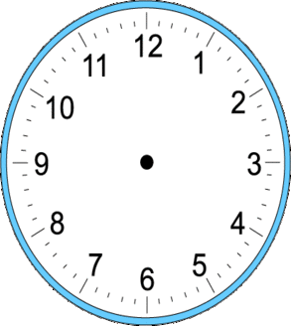
8 o’clock 9 o’clock half past 9 half past 4

1 o’clock 12 o’clock half past 10 half past 6

Challenge Can you make up another o’clock and half past time, write them and draw the hands?

__________________ __________________

