Maths  - Count forwards and backwards to 100  - Write and recognise numbers to 100  - Count in 2s, 5s and 10s  - 1 more & 1 less  - Addition and subtraction  - Solve one step problems involving multiplication and division  - Recognise and know the value of different coins and notes  - Measure and begin to record mass/ weight, capacity and volume  - Compare, describe and solve practical problems for mass/ weight, capacity and volume | 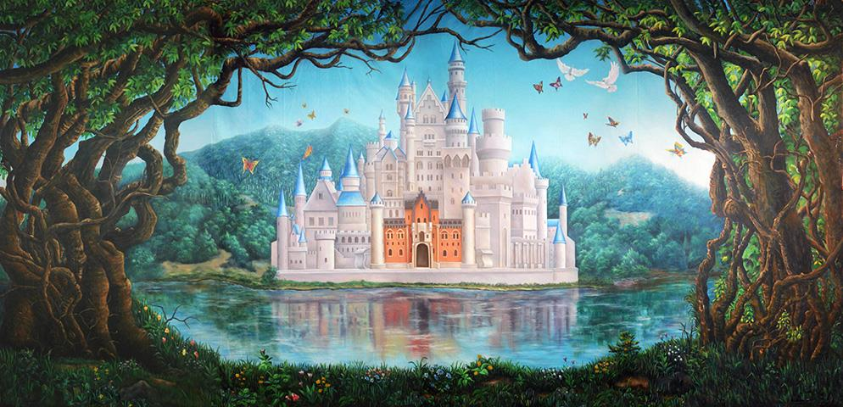  Year 1 Term 5 Once Upon a Time… | English  - Form letters correctly  - Sequence sentences  - Join ideas using ‘and’  - Use full stops, capital letter and finger spaces  - Spell words correctly  - Re-read and discuss our writing in order to improve it  - Listen to and discuss a range of stories and poems  - Retell a familiar story  - Develop vocabulary  - Use phonic knowledge to decode words when reading  - Re-read books to build up fluency
Science: Seasonal changes  - Observe changes across the 4 seasons  - Observe and describe weather associated with the seasons and how day length varies |  | Computing  - Create and debug simple programs  - Use logical reasoning to predict the behaviour of simple programs  - Communicate safely and respectfully
RE  - Why is the church an important place for Christians?  - Why and how do special places and symbols help people show what they believe?  - What places are special to me? | Music  - Use our voices expressively and creatively by singing songs and speaking chants and rhymes  - Play tuned and untuned instruments musically  - Listen with concentration and understanding to a range of high-quality live and recorded music | PHSE  - Tell you the people who are important to me  - Tell when I am feeling proud or jealous  - Think of ways to make me feel better when I feel hurt, without hurting others.
Art and Design – Paul Klee  - Find out about the work of a range of artists  - Develop a wide range of art and design techniques in using colour, pattern, texture, line, shape, form and space | PE  - Master basic movements including running, jumping, throwing and catching  - Participate in team games, developing simple tactics for attacking and defending. | Design and Technology  - Design, make, evaluate and improve structures including mechanisms

Homework will continue to be sent home each week on a Friday. This will be in a named plastic wallet in
your child’s book bag. You will also find a comment sheet to let me know how they got on. Please could homework be handed in on the following Wednesday in order that I can mark it. Thank you.

Please continue to read with your child as much as possible (at least 3 times a week, please sign or comment
in their Reading Journal) and encourage them to use the Mathletics website at home. Reading books will be changed by a member of staff once a week; please support your child as they re-read their books several times as this will help develop their fluency and expression.

As ever, your child will also need their book bag (with Reading Journal), water bottle, plimsolls and PE kit (including trainers) in school every day (all items clearly named, please!) PE kit consists of a white t-shirt and black shorts. Leggings or jogging bottoms may also be included in case of cold weather, and your child will need a plain t-shirt in their house colour for Sports Day and other events. Please note it is essential your child has a pair of trainers in school for outdoor PE lessons this term.

Thank you to all those parents who are supporting their children coming into the cloakroom independently in the mornings, this is very important as the children prepare for Year 2. Monday mornings will continue to be parent’s mornings when you are welcome to accompany your child into the classroom at the start of the day until registration.

Thank you for your continued support, please do not hesitate to contact me if there is any further information you require.

Mrs Sarah McNaught

Please continue to read with your child at home as much as possible (at least 3 times a week) and record this in their Reading Journal.

End of Year 1 Reading Expectations:

Decode words by:

- Using phonic knowledge to segment and blend sounds
- Recognising ‘tricky words’ which cannot be sounded out
- Read words ending in –s, -es, -ing, -ed, -er and
-est
- Reading words of more than one syllable
- Reading contractions such as I’m, I’ll and we’ll
- Re-reading books to develop fluency

Show I understand what I read by:

- Listening to and discussing a wide range of
poems, stories and non-fiction at a level beyond that at which I can read independently
- Linking what I read to my own experiences
- Becoming familiar with a range of traditional
tales and fairy stories, and being able to re-tell them
- Recognising and joining in with predictable
phrases
- Knowing some rhymes and poems by heart
- Talking about new words
- Checking what I am reading makes sense
- Predicting what might happen next in a story
- Making inferences on the basis of what is said
or done in a story

