Learning Goals: I can retrieve information from the text.  lazy, favourite, dirty, fetch | Independent Paired work  Group work Supported  Verbal Feedback
Fiction – Farmer Duck –Week 1
- What did the farmer do all day?
- What did the farmer eat in bed?
- What did the farmer ask the duck?
Extension choice 1 - Use the new vocabulary in sentences of your own.
Extension choice 2 – Draw the duck fetching the cows, the sheep and putting the hens in their hen house.

Scaffolding for Silver
Learning Goals: I can retrieve information from the text.  lazy, favourite, dirty, fetch | Independent Paired work  Group work Supported  Verbal Feedback
Fiction – Farmer Duck –Week 1
- What did the farmer do all day?
- What did the farmer eat in bed?
- What did the farmer ask the duck?

- The farmer _________________________________________________.

- The farmer ate ______________________________ in bed.

- The farmer asked the duck _____________________________________.

Extension choice 1 - Use the new vocabulary in sentences of your own.
Extension choice 2 – Draw the duck fetching the cows, the sheep and putting the hens in their hen house.

Scaffolding for Bronze
Learning Goals: I can retrieve information from the text.  lazy, favourite, dirty, fetch | Independent Paired work  Group work Supported  Verbal Feedback
Fiction – Farmer Duck –Week 1
- What did the farmer do all day?
- What did the farmer eat in bed?
- What did the farmer ask the duck?

1. | The farmer
worked hard. |  | stayed in bed. | went to town. | watched the television.

2. | The farmer ate ________________________in his bed.
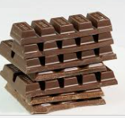  chocolate |  | bacon  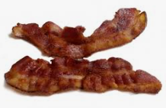 | bread  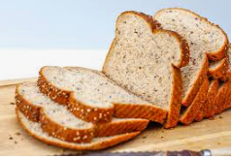 | eggs

3. | The farmer asked the duck,
“How is it going?” |  | 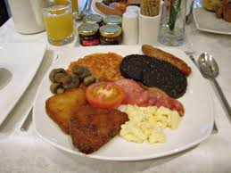  “Can I have some food?” | 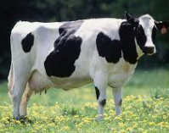  “Will you fetch the cow?” | 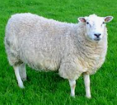  “Will you fetch the sheep?”

Extension choice 1 - Use the new vocabulary in sentences of your own.
Extension choice 2 – Draw the duck fetching the cows, the sheep and putting the hens in their hen house.

