

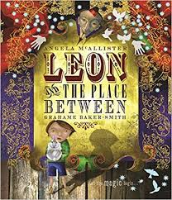

**Leon and the Place Between**

Leon, Tom, Pete and Little Mo were sat on the grass inside the Big Top waiting for the show to start.

“I don’t believe in magic,” said Tom and Pete agreed with him. Leon saw that Little Mo was sad.

“It is real Mo, just you wait and see. It’s real if you believe in magic,” Leon said gently.

The stage got dark and the audience went quiet. There were movements across the stage and the audience knew something magical was about to happen. The curtains began to twitch, and they opened to show the magnificent stage.

Three jugglers flew onto the stage spinning, tumbling and whirling together as they went. The stage music grew louder and louder, and the juggler’s sparkly suits glittered in the bright lights. Their skills made the audience cheer as they threw their skittles in the air with great speed.

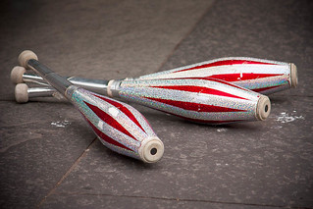





**Leon and the Place Between**

Leon, Tom, Pete and Little Mo were sat on the grass inside the Big Top waiting for the show to start.

“I don’t believe in magic,” said Tom and Pete agreed with him. Leon saw that Little Mo was sad.

“It is real Mo, just you wait and see. It’s real if you believe in magic,” Leon said gently.

The stage got dark and the audience went quiet. There were movements across the stage and the audience knew something magical was about to happen. The curtains began to twitch, and they opened to show the magnificent stage.

Three jugglers flew onto the stage spinning, tumbling and whirling together as they went. The stage music grew louder and louder, and the juggler’s sparkly suits glittered in the bright lights. Their skills made the audience cheer as they threw their skittles in the air with great speed.