**Numeracy Units:**

Multiplication and division

Measurement – finding the area

Fractions

**Literacy**

Fiction –Story of the Willow Pattern

Non-fiction – instruction and letter writing

SPAG (Spelling, Punctuation and Grammar) –expanded noun phrases

**Science: Sound**

Identify different sounds

Explain how sound travels

Change the volume and pitch of instruments

Investigate which materials are best at muffling sound

**History**

Introduction to the Shang Dynasty, looking at where and why they settled where they did.

Life at the time- food and living.

Gods and religious beliefs.

Shang Kings and their influences.

**ICT:**

Gooseberry planet – e-safety

Year 4 Term 3

The Shang Dynasty

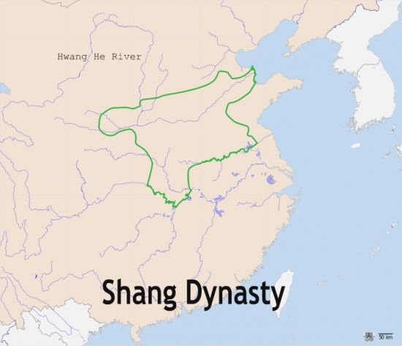



**French:**

Saying our age

**Music:**

Recorder

**DT:**

Chinese food and cooking

**PSHE & SEAL:**

Getting on and Falling out

**PE:**

Swimming

Paralympic sports/hoop ball

**RE:**

How do stories convey messages to me?

**CLASS ASSEMBLY:**

**Thursday 7th February 2.40pm**

Gymnastics