Frozen North
Term 1 - Weeks 3-7
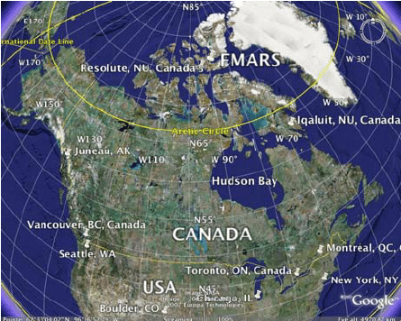

As writers:  Non-chronological reports.  Fables.  The 8 word classes.  Sentence types and structures.  Speech. | As Athletes:  Swimming  Tag rugby | As Readers:  The power of words – words that have made an impression on us.  Book reviews.  Making accurate predictions.  Using inference to identify character emotions.  Exploring vocabulary for an impact on the reader. | As Mathematicians:  Number and place value  Times table fluency  4 operations  Time zones  Scaling
As citizens:  Identify goals, fears and worries for the year.  I know there are universal rights for all children.  I understand my actions affect other people globally.  I can make choices about my behaviour and understand how behaviour can impact on a group.  I understand how being in a democracy and having a voice benefits school. | As Scientists:  Evolution and inheritance:  Recognise that living things have changed over time and that fossils provide information about living things that inhabited the Earth millions of years ago.  Recognise that living things produce offspring of the same kind, but normally offspring vary and are not identical to their parents.  Learn about important people and theories helping to shape scientific ideas.  Understand how science can support or refute ideas.  Research human evolution.  Identify how plants and animals are suited to their environment and understand how adaptations can be beneficial or not. | As Linguists (French):  Talking about me:  My school  My family  My likes and dislikes. | Religious Education:  Learn about the main features of a mosque and the meanings and symbolism connected to these features.  Consider what makes a place special  Consider what it means to belong to a community  Consider their values in connection to the clothing they wear  Reflect on their attitudes to the cultures and practices of other parts of the world  Begin to investigate the issues and arguments around the treatment of women in Islam.  Be challenged to reconsider some media stereotypes.
As Computer Experts:  Using a variety of sources to research accurately.  What are reliable sources of information. | As Geographers:  Identify world continents and oceans.  Identify the significance of world lines and time zones.  Identify compare and contrast constitute States of America.  Identify the geographical features of the Antarctic circle.  Compare and contrast different countries populations.  Recognise and describe the key geographical features of a peninsula.  Explore biomes and their locations, physical features, diversity and the effects of human processes.  Explore topographical mapping and its purpose  Explore the physical features of the Inuit tribe and comparison to our lives. | As Musicians:  Listening to and appreciating music – Peter and the Wolf. | As Artists:  Inuit art – Kenojuak Ashevak  Exploring lines  Explore mark making with a variety of found materials, which could be different pens and pencils, paper and natural things.  Using colour for character impression.

Key Vocabulary: | Fossils, classifying, inheritance, variation, adaptation, evolution, dominant, recessive.  Inhabit, diversity permafrost, ecosystems, hibernate, migrate, clusters, terrestrial, situated, nutrients, latitude, longitude, indigenous, populous, sparsely, metropolitan, biome, settlement

Curriculum Drivers: | Curiosity: | Knowledge of the wider world: | Aspirations:
 | What is life like for people elsewhere in the world?  Why do we tell stories? | Exploration of another group of people and how our lifestyles differ.  Exploration of an area of the world different to the UK. | Reference to key scientists and their discoveries.

