Theme:
Ancient Maya
Term 5
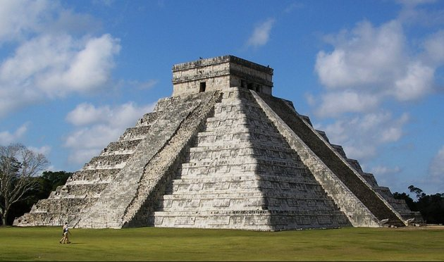
Home learning: | Reading for raffle prizes – 3 times a week minimum  Spellings homework  Homework choice grid - a minimum of 3 over the Term.

Lesson Breadth:
As writers:  Understand the purpose of instructional texts.  Engage the reader using a variety of written techniques.  Adopt a writing style suited to the target audience.  Texts:  Class reader: Shark Caller |  | As historians  Use sources of evidence to deduce information about the past.  Use sources of evidence to form hypothesis about the past.  Analyse evidence to justify claims about the past.  Show awareness of propaganda and how historians must understand the social context studied.  Identify continuity and change in history.  Compare some of the times studied with other areas of interest around the world.  Derive the cultural, social and ethnic diversity of past society.  Understand dates and terms accurately.  Use appropriate historical vocabulary to communicate. | As artists  Use appropriate shapes needed to build bodies.  Use several different techniques to refine sketching.  Experiment with the correct proportions.  Explore shading techniques.  Explore watercolour techniques. | As scientists:  Describe how living things are classified into broad groups according to common observable characteristics and based on similarities and differences, including micro-organisms, plants and animals.  Give reasons for classifying plants and animals based on specific characteristics.  Explore classification systems in more detail.  Discuss reasons why living things are placed into one group and not another.  Find out about the work of scientists such as Carl Linnaeus.  Use classification systems.
As readers:  Understand and explore the meaning of words in context.  Ask questions to improve understanding  Draw inferences.  Make predictions from what is stated and implied.  Summarise ideas.  Justify ideas  Participate in book talk.  Discuss and evaluate how writers use language, considering the impact on the reader.  Compare and contrast ideas accurately.  Texts: Revision texts – SATs.  Voices in the park. |  | As computer Experts:  Understand what it means to be a digital citizen.  Explain the difference between private and personal information.  Explain why it is risky to share private information online.  Identify the reasons why people share information about themselves online  Choose what information about themselves is safe to share online.  Create an interactive computer program that expresses who they are with text and custom images. | Being physically active:  Rounders - explore bowling and batting.  Work as a team to field effectively  Understand and apply rules of rounders.  Ultimate Frisbee – understand the rules of the game.  Develop attacking and defending techniques.  Work as a larger team effectively.  Our PE days are: Monday and Tuesday | As citizens (PSHCE):  I can recognise stress and the triggers that cause this and I understand how stress can cause drug and alcohol misuse.  I know that it is important to take care of my mental health  I know how to take care of my mental health  I understand that there are different stages of grief and that there are different types of loss that cause people to grieve  I can recognise when people are trying to gain power or control  I can judge whether something online is safe and helpful for me  I can use technology positively and safely to communicate with my friends and family
As musicians:  To identify inspirational women in the music industry. |  | As Mathematicians:  Algebra  Ratio and proportion  Revision | Religious Education:  To compare similarities and differences between how commitment to a faith is expressed. | As linguists (French):
Key Vocabulary: | Cyberbullying, digital citizen, up stander, hardwired, personal information, private information, register (online), classification, species, organism, micro-organism, multicellular organism, bacteria, nucleus, chlorophyll, photosynthesis, spore, vertebrate, invertebrate, variation, abandoned, overpopulated, uninhabitable, traditions, irrigation, terracing, anthropologists, innovations, codices, conquistadors, architects, agriculture, expansion, yields, sacrifice, ceremony.

Curriculum Drivers: | Curiosity: | Knowledge of the wider world: | Aspirations:
 | What were ancient civilisations like?  How did they compare to European life at the time?  What has continued and changed over time?  How has science had an impact on my life today? (penicillin) | What are other areas in the world like?  What are other cultures in the world like? | I know there are jobs which explore the past – anthropologists, historians and archaeologists.

