English:
Fiction – Narrative – ‘The Twits’ and Playscripts based on the same text.
Non-fiction – Recounts linked to volcanoes and earthquakes
SPAG (Spelling, Punctuation and Grammar) – fronted adverbials, punctuating direct speech.

Music: Recorder and singing

Science: Electricity
Building simple circuits
Identifying conductors and insulators
Making switches
Identifying dangers associated with electricity

Modern Foreign Language: French – numbers 12-31.

P.E: Swimming and Dance
Numeracy:
Division – divide 2 digit numbers by 1 digit numbers
Area – find the area of rectilinear shapes by counting squares
Fractions – count up and down in hundredths, recognise and show equivalent fractions, add and subtract fractions with the same denominator, solve fraction problems
Decimals – recognise and write decimal equivalents – ¼, ½.3/4 and any number of tenths and hundredths, divide whole numbers by 10 and 100, compare and order decimal numbers, round decimals to the nearest whole number.

Art: Vincent Van Gogh – artist study

ICT: Gooseberry Planet (e-safety)

R.E: What is Sikhism?

PSHCE: Going for Goals (SEAL)

Volcanoes and Earthquakes
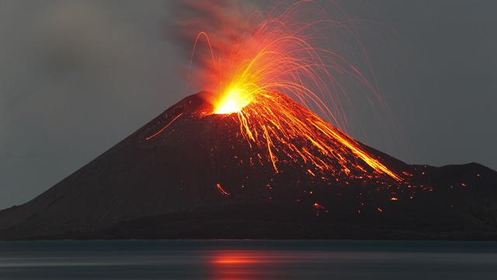
Year 4, Term 4
Geography: Volcanoes and Earthquakes.
- To know the meaning and understand the terminology related to Volcanoes and Earthquakes.
- To Understand the structure of the earth/volcanoes
- To understand plate tectonics
- To understand how and why volcanoes and earthquakes occur

Homework: Set every Wednesday to be handed in the following Tuesday morning, English (20 mins) and Maths (20mins) are set weekly. In addition to set homework, children should spend 20 minutes reading at least 3 times a week.

Art/D.T: Tudor Rose, Tudor Houses, Tudor Clothing

