Maths  - Count forwards and backwards  - Read and write numbers as numerals and words  - Count in 2s and 5s  - Addition and subtraction  - 2D and 3D shapes | 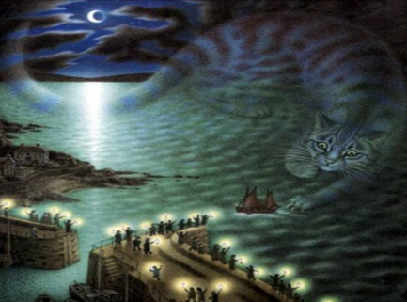  Year 1 Term 2  The Mousehole Cat |  | Art: Henri Matisse  - Find out about the work of a range of artists  - Use a range of materials creatively  - Develop a wide range of art and design techniques in using colour, pattern, texture, line, shape, form and space
Science: Seasonal changes  - Observe changes across the 4 seasons  - Observe and describe weather associated with the seasons and how day length varies | English  - Form letters and numbers correctly  - Compose sentences orally before writing  - Listen to and discuss a range of stories and poems  - Retell a familiar story  - Develop vocabulary  - Use full stops, capital letter and finger spaces  - Spell the days of the week  - Join clauses using ‘and’  - Use phonic knowledge to decode words when reading  - Re-read books to build up fluency |  | PE  - Master basic movements including running, jumping, throwing and catching, as well as developing balance, agility and co-ordination, and begin to apply these in a range of activities  - Participate in team games, developing simple tactics for attacking and defending
Geography  - Name, locate and identify characteristics of the 4 countries and capital cities of the United Kingdom and its surrounding seas  - Locate hot and cold areas of the world in relation to the Equator and the North and South Poles | History  - Understand changes within living memory | RE  - Why do Christians love stories about Jesus?  - Who is important to me? | PSHE  - Understand what makes a good friend  - Listen well to other people and work well in a group  - Know when I am starting to feel angry and how I can calm myself down  - Know how to make up with a friend when we have broken up

Homework
Homework will be sent home each week on a Friday. This will be in a named plastic wallet in your child’s book bag. You will also find a comment sheet to let me know how they got
on. Please could homework be handed in on the following Wednesday in order that I can mark it. Thank you.

Please also continue to read with your child as much as possible, and encourage them to use the Mathletics website at home. Reading books will be changed by a member of staff once a week; please support your child as they re-read their books several times as this will help develop their fluency and expression.

As ever, your child will also need their book bag (with Reading Journal), water bottle, plimsolls and PE kit (including trainers) in school every day (all items clearly named, please!)

Finally, we love junk modelling in Year 1 and would really appreciate the odd bag of
‘junk’. If you have any, we are also happy to take any blank scrap paper off your hands!

Thank you for your continued support, please do not hesitate to contact me if there is any further information you require.

Mrs Sarah McNaught

Please continue to read with your child at home as much as possible (at least 3 times a week) and record this in their Reading Journal.

End of Year 1 Reading Expectations:

Decode words by:

- Using phonic knowledge to segment and blend sounds
- Recognising ‘tricky words’ which cannot be sounded out
- Read words ending in –s, -es, -ing, -ed, -er and –est
- Reading words of more than one syllable
- Reading contractions such as I’m, I’ll and we’ll
- Re-reading books to develop fluency

Show I understand what I read by:

- Listening to and discussing a wide range of poems,
stories and non-fiction at a level beyond that at which
I can read independently
- Linking what I read to my own experiences
- Becoming familiar with a range of traditional tales and fairy stories, and being able to re-tell them
- Recognising and joining in with predictable phrases
- Knowing some rhymes and poems by heart
- Talking about new words
- Checking what I am reading makes sense
- Predicting what might happen next in a story
- Making inferences on the basis of what is said or done
in a story

