Learning Goal: I can retrieve information from a text.  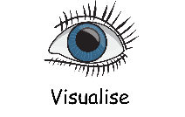  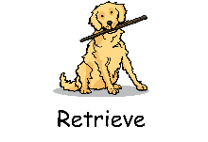  fascinate, strange, reveal, flicker | 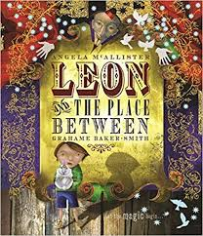  Independent Paired work  Group work Supported  Verbal Feedback
Fiction – Leon and the Place Between - Week 2
Draw the barrel organ, the monkey and the magician in the circus ring. Make sure you draw how the magician was dressed and what was happening to his fingers.
Label your picture with expanded noun phrases.

Extension choice 1 - Use the new vocabulary in sentences of your own.

Extension choice 2 – Write a list of some new magic tricks the magician could do. Use adjectives to describe the tricks.

Learning Goal: I can retrieve information from a text.  fascinate, strange, reveal, flicker | Independent Paired work  Group work Supported  Verbal Feedback
Fiction – Leon and the Place Between - Week 2
Draw the barrel organ, the monkey and the magician in the circus ring. Make sure you draw how the magician was dressed and what was happening to his fingers.
Label your picture with expanded noun phrases.

Extension choice 1 - Use the new vocabulary in sentences of your own.

Extension choice 2 – Write a list of some new magic tricks the magician could do. Use adjectives to describe the tricks.

