Literacy  Phonics: Phase 3 & 4  Non-fiction texts – transport, animals & how they move, power, road safety  Transport Stories & Poems.  Fine motor skills & letter formation activities  Labels & captions  Make own books | Foundation  Term 5 topic: Moving  Possible Lines of Enquiry  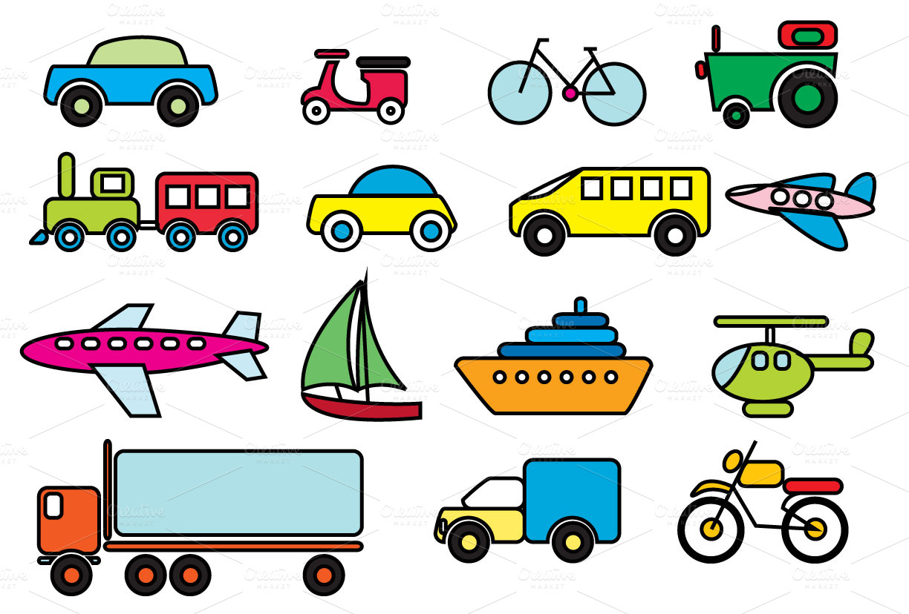 | Mathematics  Ordering Numbers 1-20  Estimating  Addition  Subtraction  Sharing  Problem solving  Length/height  Weight  Time  Patterns
Expressive Arts and Design  Circles/ tyre prints  Space Station and Bus Station role-play  Flower pictures & plant paintings  Animal art  Creating sounds to represent movement.  Moving different pieces of music/sounds  Songs to represent journeys & movement  Exploring tools & resources, role play and dressing up |  | Communication and Language  Listening to stories, nursery rhymes and songs  Discussions about Transport, my body and how I move, how animals move and keeping safe when I move.  Library group times  Following 3+ part instructions  Role play areas, being aware of the listener
Physical Development  Letter formation and Pencil Control  Name writing  Cutting  Use of outdoor large & small equipment  Large apparatus & gym work  Using our bodies  Our bodies – exercise and keeping healthy.  How does moving keep us healthy?  Tennis and ball skills | Understanding the World  ICT Skills - Develop skills to print & save work  Pilgrimages – why people travel & where to  Push and Pulls  How Plants grow  Travelling from home to school. Wheeled models  Making things that move  Water-wheels | Personal, Social & Emotional Development  Road Safety  Moving our bodies safely  Why is it important to exercise?  How do we travel to School?  Solving problems  Working together  Feelings
Characteristics of effective learning: finding out and exploring, playing with what they know, being willing to ‘have a go’, being involved and concentrating, keeping on trying, enjoying achieving what they set out to do, having their own ideas, making links, choosing ways to do things.

