STOCKHAM PRIMARY SCHOOL
THURSDAY NEWSLETTER

Issue No: 485 Thursday 19th July 2018
Dear Parents,
This will be our final newsletter for this year! The school term finishes on Wednesday 25th July at 12.10pm. Year 6 families are invited to come into school and be part of the Leaver’s assembly at 10.30am on this day.
Summer Fair
Thank you so much to the FOS for a wonderful Summer Fair. All the FOS members and school staff worked so hard to ensure we had a brilliant evening – and the rain held off too! We raised well beyond expectations, better than any previous years. It was lovely to see so many families (400 guests) enjoying the friendly atmosphere and also lovely to see next September’s Foundation class families.

Well done Mr Burbank and Flo!
After a gruelling 63 miles in the blistering heat, Flo and Mr B completed their enormous challenge and made it to the stones in Avebury. Thanks to your sponsorships and lots of fundraising, they have raised £1,640 through 77 different online donations and £246 in school fundraising. This makes a whopping total of £1,886 for ICT equipment in school. We hope that this challenge has inspired many children at Stockham School to push beyond their boundaries and Soar High!

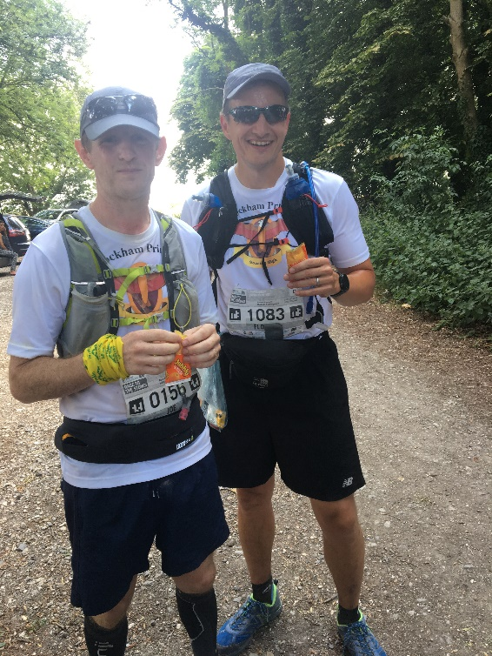

Breakfast club
The cost for attending breakfast club will be increasing in September in order to cover costs of staffing and resources. This will increase to £1 per session (8-8.40am). A separate letter will be sent out confirming these details.
Lunchtime Supervisor vacancy
We are currently looking to appoint a temporary (Sept-April) lunchtime supervisor, starting in September 2018. This position is for 5 hours a week. Please let me know if you are interested in this position and would like a copy of the job description and person spec. The successful candidate must be committed to following the school’s safeguarding and behaviour policies.
Book sale – We have a few old KS1reading books that we no longer require. Annie Davis will be holding a book sale for 10p a book in the KS1 playground on Friday after school.
INSET day on the 4th September 2018. Children return to school on Wednesday 5th September at 8.40am.
Have a wonderful Summer break!
Many thanks,
Mrs. Burbank

PA’s this week were Jessica and Joshua. Thank you for your help.

CLASS NEWS

Year F This week we have been busy preparing for our class assembly and are so proud
with how well we all did. The children really enjoyed the class picnic on Tuesday
and have done some lovely writing about their favourite part.
Year 1 In Year 1 we have been noticing the features of our local environment in
geography. In computing we have been de-bugging incorrect code, and in R.E we
have been finding out what Muslims believe about God.
Year 2 This week Year 2 have been finishing off the living things unit in science, we have
looked at different animals and their habitats. We have also been making books for
our new teacher.
Year 3 This week we had fun learning about fashion design and making newspaper hats!
We have also been learning how to tell the time to the nearest minute.
Year 4 This week Year 4 have researched Roman place names in history. In English we
have been writing a persuasive advert based on a Roman villa. In PSHCE we have
been learning about ways to help us manage money.

Year 5 This week we have been looking at area and perimeter in maths. In English we
have been writing multi-clause sentences.
Year 6 This week Year 6 have finished off science. We have been creating memory books.

Soaring High
This week the following children have earned “Soaring High”:
Year F All of Foundation for an amazing assembly. I am so proud of all of the class, they
showed off how fantastic they all are!!
Year 1 All of the Year 1 parents and carers for your support this year and for the
wonderful Flower Power projects completed this term. Thank you!
Year 2 Brandon for fantastic work in science, what a fabulous habitat picture. Matthew
for using his independence to write a fantastic adventure story.
Year 3 All of Year 3 for a fantastic year. You have all worked so hard and become so
independent around the school and in lesson time. Thank you for an amazing
year!
Year 4 Sadik and Rachel for great leaflets all about the Roman Baths.
Year 5 All of Year 5 for being an amazing class. You will all be fab Year 6’s.
Year 6 All of Year 6 for being fantastic. You have had an amazing year and I wish you
lots of luck on your new adventure.

Well done everyone!

Tidy Tiger
This week Tidy Tiger goes to Val and Mrs B for having the tidiest room. Well done!

Attendance Ted
Attendance Ted was awarded to Foundation for having the best attendance last week, they will be looking after Attendance Ted next week. Well done Foundation!

School Uniform
If you need new uniform please order online or by telephone. The website is pmgschoolwear.co.uk and the order line is 0800 4046644.
Book bags and PE bags are also available to be purchased from pmgschoolwear.

