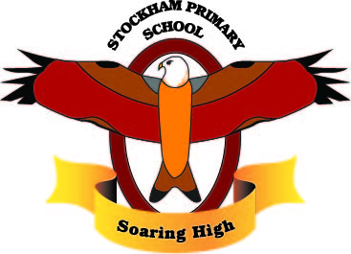
Theme: From Field to Fork

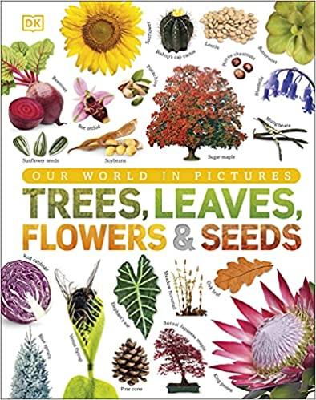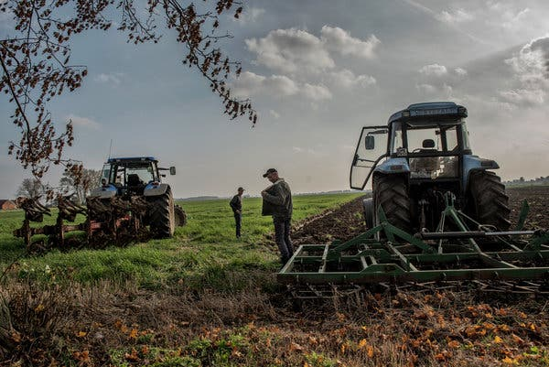
Breadth:

As writers:  - Write legibly using appropriate joins.  - Plan, draft, edit, improve and proof-read our writing.  - Use paragraphs to organise our work.  - Use nouns, pronouns, conjunctions, adverbs, fronted adverbials, prepositions, possessive apostrophes and direct speech.  - Spell homophones and commonly misspelt words correctly.  - Use dictionaries to check the spelling and meaning of words.  - Write an information leaflet about Plants. |  | As Athletes: Swimming  - Entering and resurfacing in the water.  - Controlling breathing.  - Floating.  - Turning.  - Moving to safety in the water and exiting.  - Working on the 5 strokes.  Athletics  - Running, jumping, throwing.  - Develop flexibility, strength, technique.  - To sprint effectively.  - Run with fluency over hurdles.  - To jump for distance.  - Learn different push throw techniques. | As Artists: Fruit and Vegetable Art  Carl Warner and Caravaggio.  - Draw detail carefully.  - Talk about well known fruit and vegetable paintings.  - Show colour.  - Use paint to show cross sections.  - Look at the work of Carl Warner and Caravaggio. | As scientists: Plants  - Name the different parts of flowering plants and explain their function.  - Set up an investigation to find what plants need to grow well.  - Investigate how water is transported in plants.  - Explain the role of the different parts of a flower in pollination, seed dispersal and fertilisation.  - Understand and order the life cycle of a plant.
As readers:  - Read and listen to a wide range of styles of text.  - Listen to and discuss a wide range of texts.  - Use texts to infer, predict, explain, retrieve, summarise.  - Ask questions to improve understanding of a text.  - Retrieve and record information from non-fiction, using titles, headings, sub-headings and indexes. |  | As Mathematicians:  - Recall and use multiplication and division facts for the 3, 4 and 8 multiplication table.  - Shape- turns and angles, right angles in shapes, compare angles, horizontal and vertical, perpendicular and vertical, 2D and 3D shapes.  - Measurement- compare, measure, add and subtract mass.  - Measurement- compare volume, measure, compare, add and subtract capacity.  - Temperature | As linguists (French):  - Ask Please May I have?  - Preferences  - What Colour is it?  - What did he eat? | As musicians: Bringing Us Together  - Listen and appraise;  Bringing Us Together by Joanna Mangona and Pete Readman Good Times by Nile Rodgers Ain’t Nobody by Chaka Khan We Are Family by Sister Sledge  - Sing, play and improvise  - Compose songs using instruments.
As computer Experts:  - Develop sequential algorithms.  - Begin to use the de-bugging process.  - Use loops to more easily communicate instructions.  - Draw images by using simple loop instructions. |  | As Geographers:  - Locate and label the equator and the tropics.  - Describe the climate in the tropics.  - Label the hemispheres.  - Define the term food miles.  - Understand what the most traded foods are globally.  - Define the words import and export.  - Understand what the world’s most traded beverage is. | Religious Education: Hinduism  - Who and Where?  - Main Beliefs  - Special places  - Special festivals  - Holy books  - Symbols and meanings | As citizens (PSHCE): Changing Me  - How Babies Grow  - Babies  - Outside Body Changes  - Inside Body Changes  - Family Stereotypes  - Looking Ahead
Key Vocabulary: | Sustainability, biomes, Northern Hemisphere, Western Hemisphere, Eastern Hemisphere, climate, climate zone, longitude, latitude, arid, temperate, tropical, Mediterranean, seasonality, human features, physical features, international trade, import, export, beverage, food miles, food security, water transportation, life cycle, seed dispersal, function, flowering plant, root, stem, nutrients, pollination.

Curriculum Drivers: | Curiosity: | Knowledge of the wider world: | Aspirations:
 | - What happens on a working farm?  - What do farmers grow and produce that we eat?  - What is the meaning of field to fork?  - Why are plants so important to us?  - Where does our food come from? | - What are farms like around the world?  - What is a temperate, tropical and Mediterranean climate?  - How do we describe different locations around the world?  - How is food produced and traded around the world?  - How does fair trade help farmers? | - What would it be like to work on a farm?  - What are the job responsibilities of a farmer?  - Who does a farmer work with?  - What equipment does a farmer use?

