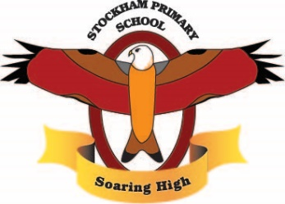
Theme:
Hooray for Heroes!
Term 1
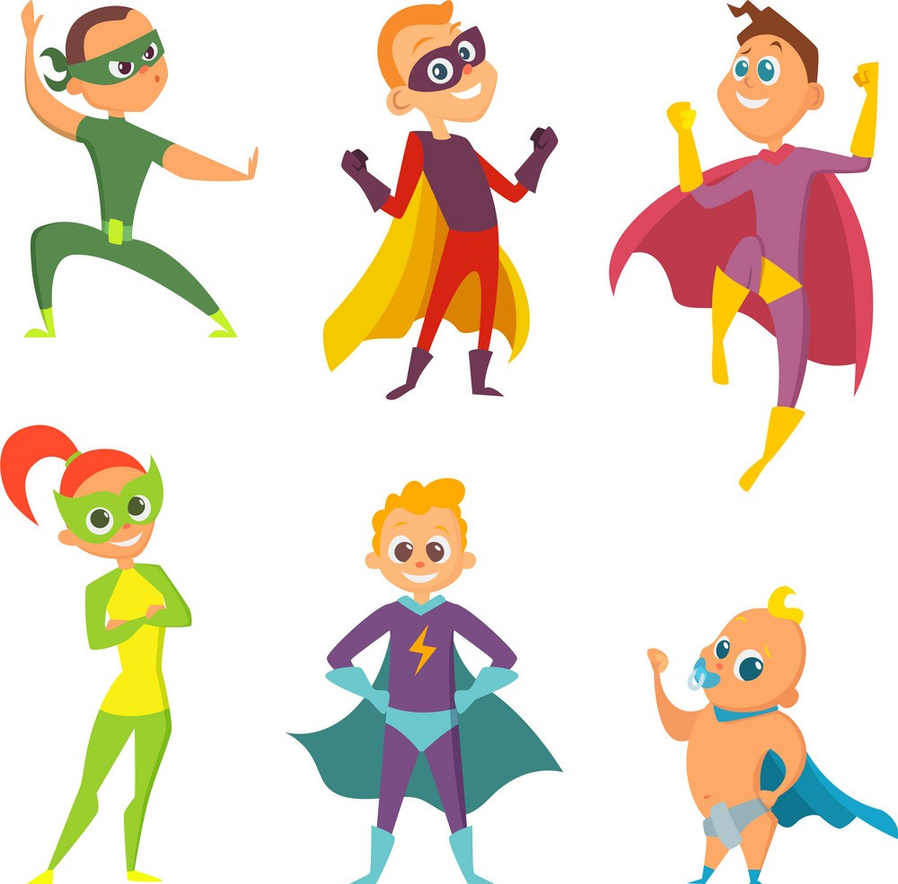

Breadth:

As writers:  Segment spoken words into phonemes, spelling many correctly.  Learn new ways of spelling phonemes for which one or more spelling can be used.  Write narratives about personal experiences and those of others (fictional).  Write simple discussion pieces about a character.  Proof reading to check for errors in spelling and punctuation. |  | Being physically active:  Master basic movements and begin to apply these in a range of activities.  Participate in team games, developing simple tactics for attacking and defending.  Our PE days are: Mondays and Tuesdays. | As computer Experts:  Identify examples and uses of computers.  Identify examples of IT and how and why it is used.  I can identify how to use IT safely. | As scientists:  Understand the importance of exercise.  Understand what a balanced diet is.  understand the importance of hygiene for humans.  Make simple predictions.  Make observations and understand observations can take place over time.  Perform simple tests.  Gather and record data.
As readers:  Apply phonic knowledge and skills as the route to decode words until automatic decoding has become embedded and reading is fluent.  Read accurately by blending the sounds in words.  Read accurately words of two or more syllables.  Listen to, discuss and express views about stories at a level beyond that at which they can read independently.  Discuss the sequence of events in stories.  Become increasingly familiar with retelling stories.  Answering and answering questions. |  | As Historians:  Observe or handle evidence to ask questions and find answers to questions about the past.  Ask questions such as:  What was it like for people?  What happened? How long ago?  Use artefacts, pictures, stories, online sources and databases to find out about the past.  Identify some of the different ways the past has been represented. | As Artists:  Respond to ideas and starting points.  Explore ideas and collect visual information.  Show patterns and texture (drawing).  To take inspiration from the greats (classic and modern) | As citizens (PSHCE):  I can identify some hopes and fears.  I recognised when I feel worried and know how to ask for help.  I know my rights and responsibilities in class and school.  I can listen and contribute to discussions.  I can work cooperatively.  I recognise the choices I make and understand the consequences.
As design technologists:  Create a simple food dish  Understand the design process: think, make, break and repeat  Label and annotate pictures with design features.  Apply your knowledge of techniques to make prototypes and plan how the dish will be made.  Evaluate the look of your design to see if it has any weaknesses.  Modify your recipe and explain your decisions.  Describe the safety features to be taken into account when preparing food. |  | As Mathematicians:  Number and Place Value  Count in steps of 2, 3 and 5 from 0 and in tens from any number, forwards and backwards.  Recognise the place value of each digit in a to-digit number.  Identify, represent and estimate numbers using different representations.  Compare and order numbers from 0 to 100 and use the <, > and = symbols.  Read and write numbers to at least 100 in numerals and words.  Use place value and number facts to solve problems. | As Mathematicians:  Addition and Subtraction  Solve problems with addition and subtraction.  Recall and use addition and subtraction facts to 20 fluently and derive and use related facts up to 100.  Add and subtract numbers using concrete objects, pictorial representations and mentally.  Show that addition can be done in any order but that subtraction cannot.  Recognise and use the inverse relationship between addition and subtraction. | As musicians:  Talk about songs I like and how they make me feel.  Find and keep a steady beat.  Move, dance and perform actions along to music.  Copy and clap back rhythms.  Clap the rhythm of your name.  Create rhythms of long and short.
As Geographers:  Use atlases, globes and world maps to identify the physical features of planet earth.  Identify where wild fires happen and what conditions are needed. |  | Religious Education:  Share why a book is special to me.  Name and recognise the Bible as the special book of the Christian community.  Retell stories from the Bible.  Suggest meanings for the Christian community and impact the stories have on believers’ lives.
Key Vocabulary: | Automatically, fluency, inspiration, purpose, user, observations, predictions, balanced, continents, physical features, Decades, congested, flammable, architects, eyewitness, extract

Curriculum Drivers: | Curiosity: | Knowledge of the wider world: | Aspirations:
 | We will find out about planet Earth and what makes it an amazing place.  We will talk about our talents and what makes us special as individuals. | We will find out about local heroes.  We will learn about the impact fires can have on different areas. | We will meet local fire fighters and learn about their job roles.  We will discuss and embed the skills represented by learning powers and use these successfully throughout the term.

Home learning: | Homework folders will be sent home. Please complete one piece each week for the term.  Reading or being read to as much as possible (ideally every day!) at home.

