STOCKHAM PRIMARY SCHOOL
THURSDAY NEWSLETTER

Issue No: 516 Thursday 13th June 2019
Dear Parents and Carers,
We are delighted to announce that Stockham School, have achieved the School Games Platinum Mark Award for the 2018/19 academic year. The School Games Mark is a Government led award scheme launched in 2012, facilitated by the Youth Sport Trust to reward schools for their commitment to the development of competition across their school and into the community, and we are delighted to have been recognised for our success. Well done to Mrs Cargill for all her hard work ensuring that the school achieved this wonderful award!
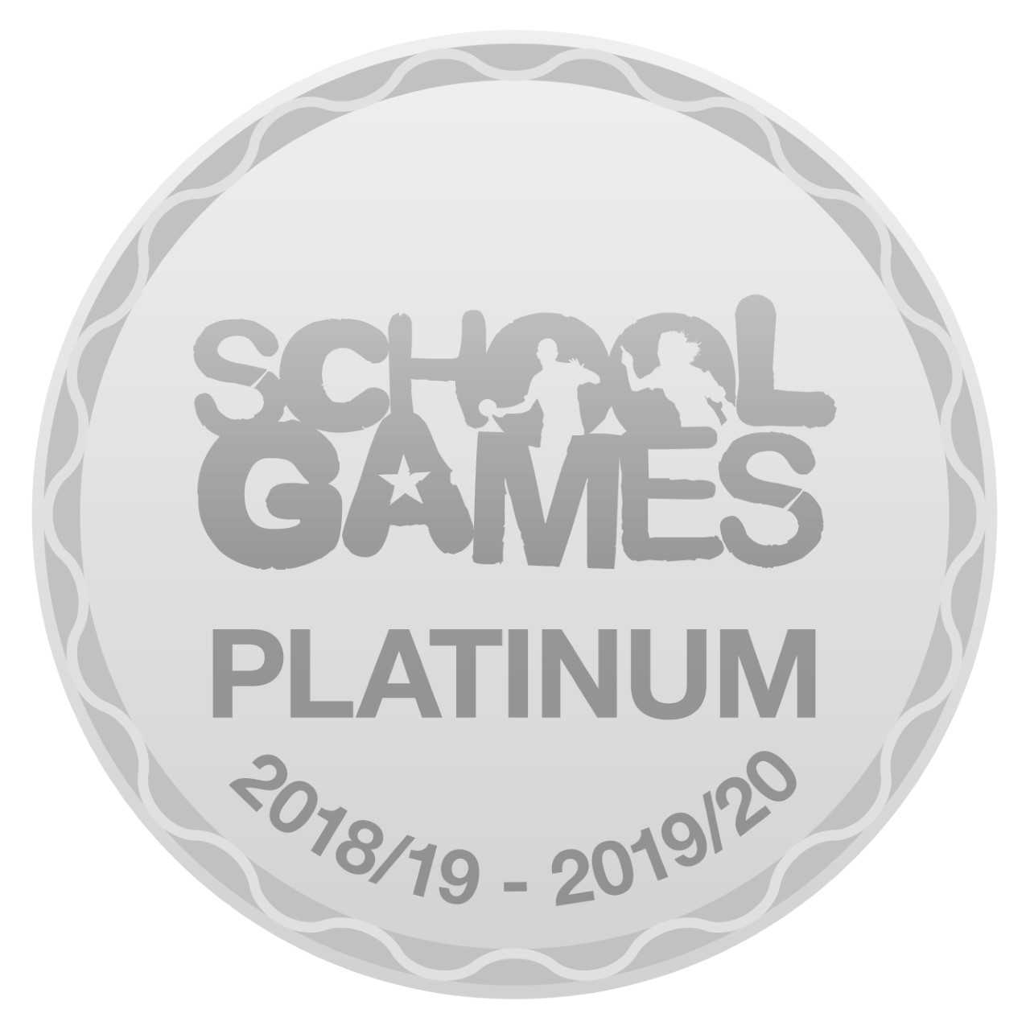

Thank you to Jenny Hannaby (our school governor) and the KS2 staff team for taking the children to watch the OVO Energy Women’s Cycling Tour. It was a long wait due to an accident delay, but great fun when they passed through Challow Road!
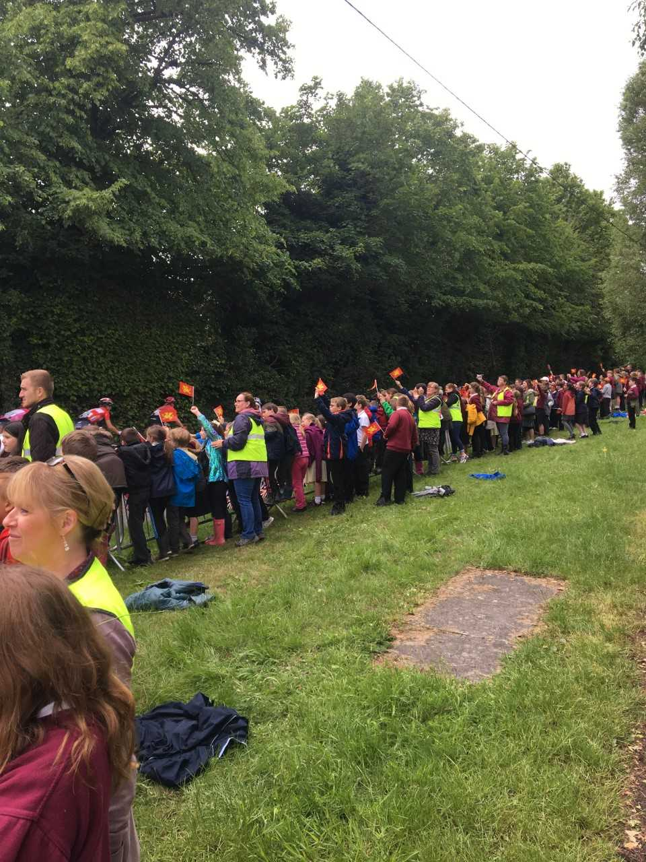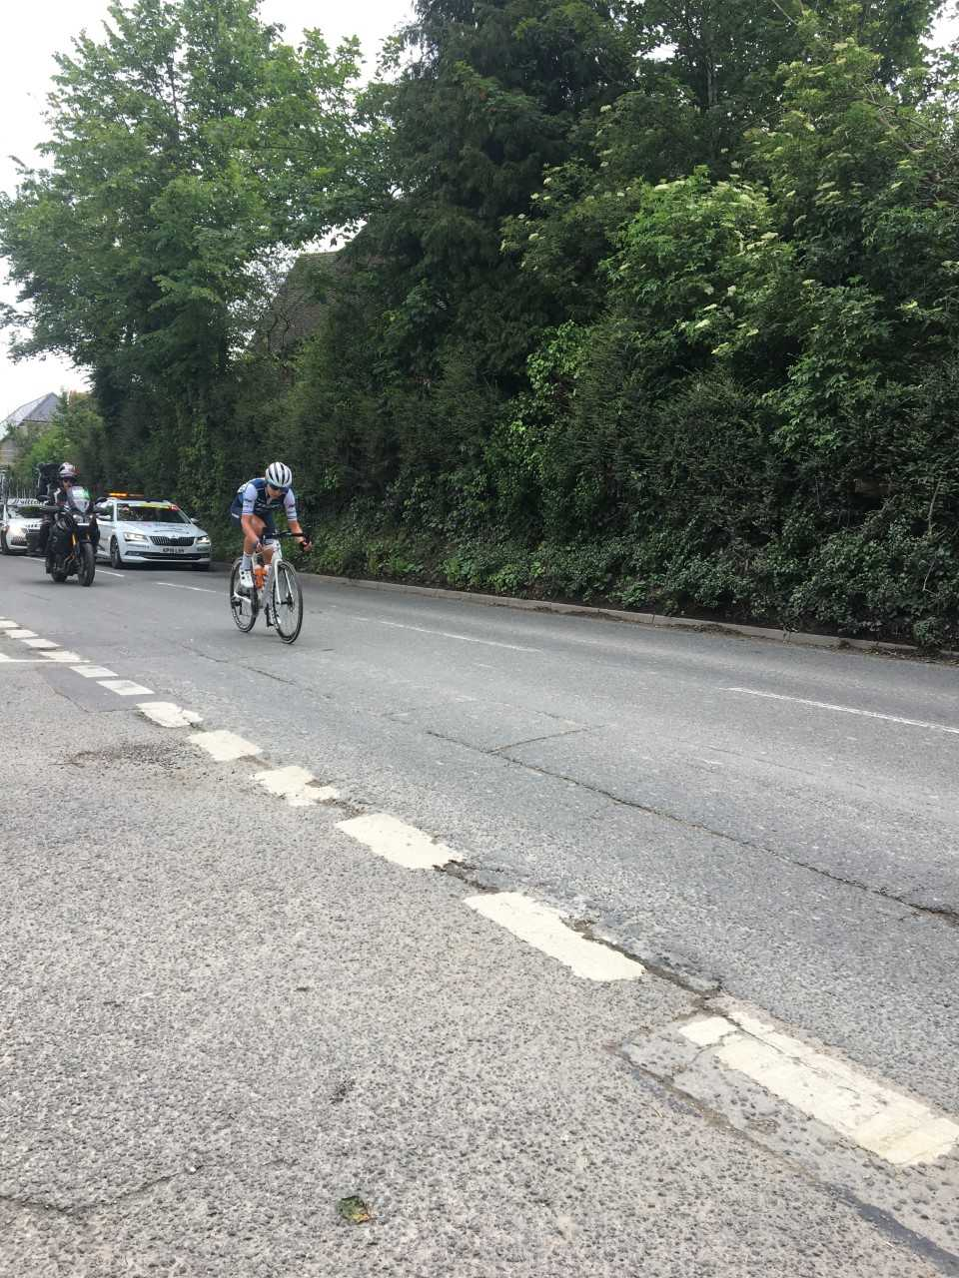

Still to come:
14th-17th June– Year 6 trip to PGL Osmington Bay
20th June – Year 1 trip to Cotswold Water Park
21st and 24th June –School closed INSET days
3rd July – Year 2 trip to Marwell Zoo
4th July - Swap over afternoon – children meet new teachers and staff for next year
8th July – Whole school tennis festival
10th July – Sports day (KS1 9.15am KS2 1.15pm)
12th July – FOS summer disco and BBQ
15th July –Ambitions day. End of year school reports home to parents and carers
18th July –Year 6 leavers BBQ and Cancer research fundraiser day (more information to come)
24th July – School year ends at 12.10pm
Monday 2nd September 2019 –INSET day. Children return to school on the 3rd September at 8.40am.
Many thanks,
Mrs. Burbank

PA’s this week were Dylan & Kyle. Thank you for your help.

CLASS NEWS

Year F This week we have been learning all about Hermit crabs. The children have
enjoyed watching clips showing how the crabs change shells and where they live.
In English we have been writing facts about Hermit crabs to make our own fact
page.
Year 1 This week in maths we have been looking at quarters and halves. In English we
have been describing the whales and different characters in our story ‘The Whales
Song’.
Year 2 In maths this week we have been looking at the properties of 2D shapes and their
lines of symmetry. In English we have been reading ‘Gorilla’ by Anthony Browne
and we have written setting descriptions with adjectives.
Year 3 In English we have been writing instructions for how to mummify a body, and we
have practised by mummifying some tomatoes! In maths we have been revising
comparing and ordering tenths and equivalent fractions.
Year 4 In Year 4 we have been busy with our Cracking Contraptions topic. We have been
deepening our knowledge of The Lost Thing and thinking about how to write super
sentences by adding adjectives and clauses. In maths we have been learning about
line graphs and how to interpret the information in them. We have also really
enjoyed learning about the Wright brothers and how they designed the first
aeroplane and trying to make the 'best' paper aeroplane.
Year 5 Year 5 have started looking at our climate change topic. We have also been
looking at multi-clause sentences and decimals.
Year 6 This week Year 6 have been learning performance songs. In science we have
been looking at how the lungs work and some factors which may effect their
healthiness. We have been exploring money in PSHCE.

Soaring High
This week the following children have earned “Soaring High”:
Year F Alistair for his amazing writing. Alistair has worked really hard this week and
produced some fantastic writing. Louis for his perseverance and determination
with his learning.
Year 1 Harry H for using fantastic confidence when describing the whales from our story.
Henry for using such independence when describing the whale from the story.
Year 2 Eva and Euan for their beautiful descriptive writing in English this week. You
showed the confidence to ‘dive’ and I was so impressed with the atmosphere you
created for your piece. Well done!
Year 3 Molly P and Alfie G for great teamwork and perseverance when defeating the
zombies in our new maths game!
Year 4 George, Brooke and Isabella for designing the paper aeroplane which flew the
furthest when we tested our new designs and for demonstrating great learning
powers when working as a team.
Year 5 All of Year 5 for using their determination and team work on the Youlbury trip.
They were all amazing!
Year 6 Dylan A and Rory for their enthusiasm to learn and take part in the performance
songs.
Well done everyone!

Tidy Tiger
This week Tidy Tiger goes to Foundation for having the tidiest room. Well done!

Attendance Ted
Attendance Ted was awarded to Year 5 for having the best attendance last week, they will be looking after Attendance Ted next week. Well done!

On Wednesday 5th June, 20 children attended the Quad kids athletics competition. They were all fantastic and were a credit to Stockham school. It was fantastic not only to see the determination - particularly on the long distance run - but also to see the sportsmanship they showed by supporting each other during the activities. Over all the Year 3/4 team finished 4th and the 5/6 team finished 8th - excellent results. A big congratulations needs to be said to Evie in year 5 who was the TOP girl out of every girl at the tournament across the different schools and year 5/6. A huge achievement and we are so proud of you! Thank you to everyone who came and supported us.



