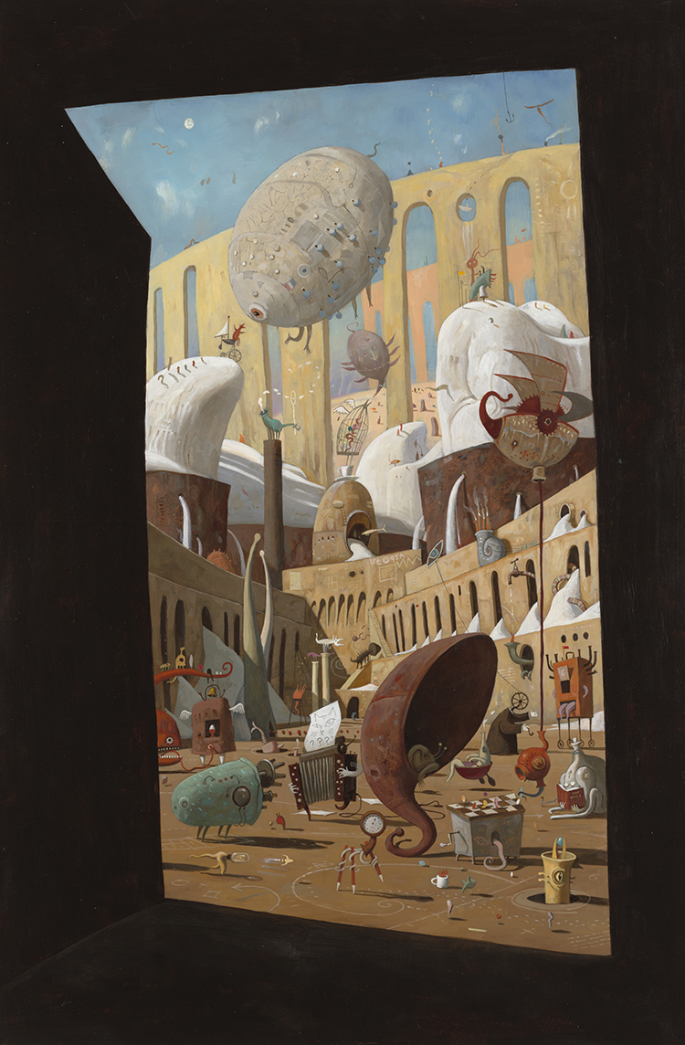
Look at the amazing image of The Lost Thing World and then write a detailed description of what you can see. Really push yourself with your word choices.
_________________________________________________________

_________________________________________________________

_________________________________________________________

_________________________________________________________

_________________________________________________________

_________________________________________________________

_________________________________________________________

_________________________________________________________

_________________________________________________________

_________________________________________________________

_________________________________________________________

_________________________________________________________

_________________________________________________________

