English  Spelling, commas, recounts, editing, revising and improving our work. | 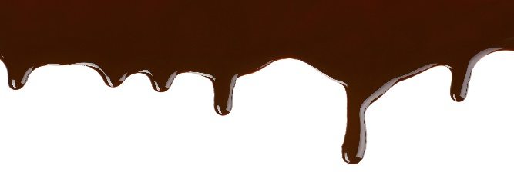  Year 2  Term 6  Chocolate! |  | Maths  Statistics, reasoning and revision of previous topics.
Science  Plants: How seeds and bulbs grow into mature plants, how plants need water, light and a suitable temperature to grow and stay healthy. |  |  | PE  Athletics and team games.
Geography
Why does it matter where my food comes from?
PSHE  Change | RE  Special people  Islam (Muhammad) |  | Computing  Organise, store, retrieve and manipulate data
DT  Healthy eating  Where does food come from? |  | Art  Charles Rennie Mackintosh

Your child will need their book bag, water bottle, plimsolls
and PE kit (including trainers) in school every day.
Children will also need a hat and suncream on sunny days.
(All items clearly named, please!)

Homework projects are due in on Monday July 10th!

Please continue to read with your child at home as much
as possible and encourage them to use the Mathletics website.

Please come along to our class assembly at
2:40pm on Wednesday 21st June!

