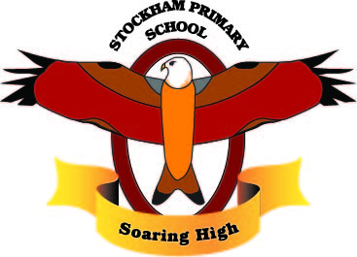
Theme/Subject: Ancient Greece/ History

Breadth:
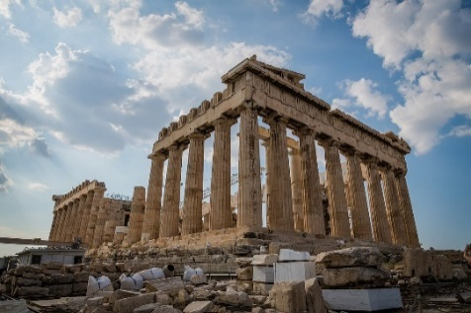

As writers: Myths  Sentence structure, adverbials, expanded noun phrases, prepositions, relative clauses, subordinating conjunctions, repetition, metaphors, similes, personification.  Texts: Theseus and the Minotaur  Class reader: Who let the Gods Out?  Poetry:  Non fiction:  Narrative: Theseus and the Minotaur |  | Being physically active: Athletics  Combine sprinting with low hurdles over 60 metres.  • Choose the best place for running over a variety of distances.  • Throw accurately and refine performance by analysing technique and body shape.  • Show control in take off and landings when jumping.  • Compete with others and keep track of personal best performances, setting targets for improvement. | As Designers:  Sculpture - pottery  - identify some of the key features of Ancient Greek pots  - use gouging and scraping techniques.  - design an Ancient Greek pot  - make and evaluate a model of an Ancient Greek pot | As scientists:  Animals – including humans  - recognise the stages in a human life cycle.  - explain different gestation periods  - describe some of the changes in childhood  - describe the changes which happen during puberty  - describe some of the changes that take place in old age
As readers:  - Recommending books  - Exploring the meaning of words  - Making comparisons  - Inferring  - Summarising |  | As Mathematicians:  - Fractions  - Decimals and percentages  - Properties of shape  - Position and Direction  - Converting Units | As linguists (French): Directions  - Describe where places are  - Give directions to a particular place in the town  - Ask for directions | As musicians: How Does Music Shape Our Way of Life?  Listening to, appreciating, understanding and performing music: Look into the Night (Pop), Breathe (Orchestral), Keeping Time (Funk)
As computer Experts: Game Developing  - Set IF conditions for movements. Specify types of rotation giving the number of degrees.  - Change the position of objects between screen layers (send to back, bring to front).  - Upload sounds from a file and edit them. Add effects such as fade in and out and control their implementation. |  | As historians:  - Where Ancient Greece was.  - The different city states that existed in Ancient Greece.  - How the different states were governed and ruled.  - What objects have survived from Ancient Greece  - The impact of the Greeks writing things down  - The influence that Greek culture had on Rome  - The cultural achievements of Greece  - The Olympic Games  - Athens was the first direct democracy  - Who had a say in the governance of Rome  - How Athenian democracy influenced the world  - The difference between Athens and Sparta.  - The Spartan elite army.  - How Athens tried to defend itself. | Religious Education:  - Know how the Bible came into being.  - Look at different versions of the Bible.  - Explore how Christians use the Bible today.  - Explore Why Jews go on Pilgrimages | As citizens (PSHCE): Changing Me  - Awareness of self-image and body  - Describe how boys’ and girls’ bodies change during puberty  - Understand that sexual intercourse can lead to conception and that is how babies are usually made – Please note parents have the right to withdraw their child from this lesson.  - Identify things to look forward to when becoming a teenage as well growing responsibilities (age of consent)  - Identify things to look forward to in Year 6
Key Vocabulary: | Democracy, citizens, philosophy, historical sources, artefacts, civilisations, democratic, characteristic features, generation, techniques, amphoras, lekythos, gouging, scraping, ‘slip’, life cycle, gestation, puberty

Curriculum Drivers: | Curiosity:  - Where is Ancient Greece?  - How was Ancient Greece states structured?  - What were the main events in Ancient Greek history?  - What can Ancient Greek pots tell us about that period of history? | Knowledge of the wider world:  - How has Ancient Greece influenced the modern world?  - How can we use artefacts and sources of information to understand Ancient Greece’s influence?  - Consider the role social media and the internet plays in our self-images. | Aspirations:  - Knowledge of different careers – historians, scientists  - Knowledge of how to make a positive impact on our community

Home learning: | Year 5 homework for this term will be the following:  - Weekly logging into Spelling Shed to practise the weekly spellings – 6 games to unlock other games – the spellings can be practiced in their homework books too.  - Weekly logging into Times Tables Rockstars – 15 minutes to release other games.  - Reading- recorded into the reading diary to be entered into the readers raffle every Thursday and Key Stage 2 readers raffle at the end of term.  - One item to be chosen from the homework menu per week, to be handed in every Thursday

