English  - Write legibly using appropriate joins.  - In narrative, create settings, characters and plot.  - Plan, draft, edit, improve and proof-read our writing.  - Use paragraphs to organise our work.  - Use nouns, pronouns, conjunctions, adverbs, fronted adverbials, prepositions, possessive apostrophes and direct speech.  - Spell homophones and commonly misspelt words correctly.  - Read our work aloud.  - Listen to and discuss a wide range of fiction, poetry, plays, non-fiction and reference books or textbooks.  - Read and understand root words, prefixes, suffixes and exception words.  - Use dictionaries to check the spelling and meaning of words. | Year 3 Term 4  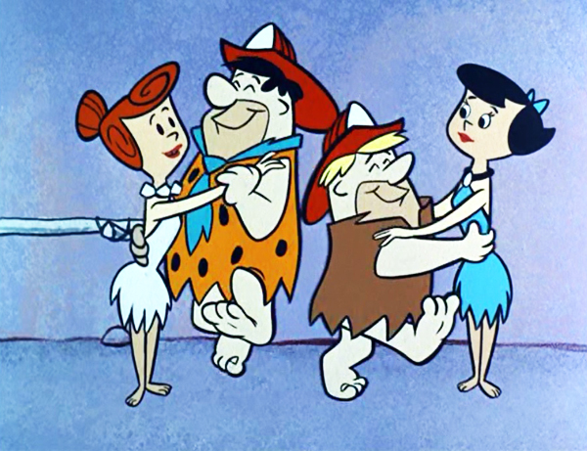  Let’s Rock and Roll! | Maths  - Interpret and present data using bar charts, pictograms and tables.  - Solve one-step and two-step questions using information in scaled bar charts, pictograms and tables.  - Add and subtract amounts of money to give change using both £ and p in practical contexts.  - Tell and write the time from an analogue clock including using Roman numerals, 12 and 24 hour clocks.  - Record and compare time in terms of seconds, minutes and hours.  - Use vocabulary such as o’clock, am/ pm, morning, afternoon, noon and midnight.  - Know the number of seconds in a minute, days in each month, year and leap year.  - Compare durations of events to calculate time taken by particular tasks.
Science: Rocks  - Compare and group together different kinds of rocks on the basis of their appearance and simple physical properties.  - Describe in simple terms how fossils are formed when things that have lived are trapped inside rock.  - Recognise that soils are made from rock and organic matter. | Art: Cave Art  - Improve our mastery of art and design techniques, using a range of materials. | Geography: Fieldwork  - Investigate rocks and soils I the local environment.
 | DT: Clay Beakers  - Design, make and evaluate products using a range of tools and materials. | History: Stone Age to Iron Age  - Learn about changes in Britain from the Stone Age to the Iron Age.
PSHCE: Changes  - Talk about some of the things that have changed in my life, and how I feel about them.  - Know that what we feel and think affects what we do  (how we behave).  - Know some of the reasons that change can feel  uncomfortable and scary.  - Know some ways of dealing with the feelings that  - sometimes arise from changes. | Computing: Online Safety  - Use technology safely, respectfully and responsibly.  - Recognise acceptable/ unacceptable behaviour.  Identify a range of ways to report concerns about content and contact. | PE: Dance  - Perform dances using a range of movement patterns.
RE
- Forgiveness and sacrifice.
- What matters to Christians about Easter?
 | French: All About Me  - Join in, speak, listen and respond | Music  - Improvise and compose music.  - Sing, play instruments and perform with increasing accuracy, fluency, control.

Homework
Homework will continue to be sent home each week on a Friday.
Please could homework be handed in on the following Thursday. Thank you!

Reading
Children are also expected to be reading at home at least 3 times a week;
please sign their Reading Journal to confirm this. Thank you!

Equipment and PE kit
As ever, your child will also need their book bag (with Reading Journal),
water bottle, plimsolls and PE kit (including trainers) in school every day
(all items clearly named, please!)

Dates for your diary
Thursday 7th March World Book Day
Monday 11th and Tuesday 12th March Parent Teacher interviews
Wednesday 27th March 2:40pm Year 3 Assembly to parents
Friday 5th April 12:10pm End of term

Thank you for your continued support, please do not hesitate to contact me
if there is any further information you require.

