Theme/Subject: Anglo Saxons/ History

Breadth:
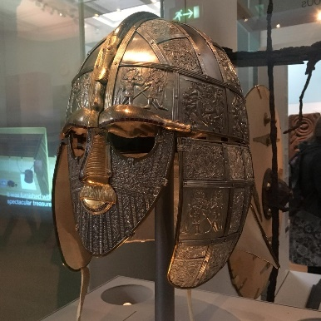
As writers: Persuasive  Sentence Structure, adverbials, noun phrases, rhetorical questions, counter arguments, metaphors, subordinating conjunctions. daisy.britten@teachingpersonnel.com  Texts:  Class reader: Kick  Non fiction: Anglo Saxon and Scots Invaders  Narrative: Kick |  | Being physically active:  Choose and combine techniques in game situation.  • Work alone, or with team mates in order to gain points or possession.  Field, defend and attack tactically by anticipating the direction of play.  • Choose the most appropriate tactics for a game.  • Uphold the spirit of fair play and respect in all competitive situations.  • Lead others when called upon and act as a good role model within a team. | As Designers:  - Understand the importance of correct storage and handling of ingredients  - Measure ingredients accurately  - Follow a recipe  - Demonstrate a range of baking and cooking techniques  - Create and refine recipes. | As scientists:  Compare and group together everyday materials based on their properties.  • Understand how some materials will dissolve in liquid to form a solution and describe how to recover a substance from a solution.  • Use knowledge of solids, liquids and gases to decide how mixtures might be separated, including through filtering, sieving and evaporating.  • Give reasons, based on evidence from comparative and fair tests, for the particular uses of everyday materials, including metals, wood and plastic.  • Demonstrate that dissolving, mixing and changes of state are reversible changes.  • Explain that some changes result in the formation of new materials.
As readers:  - Recommending books  - Exploring the meaning of words  - Making comparisons  - Inferring  - Summarising |  | As Mathematicians:  - Multiplication/ Division  - Perimeter and Area  - Fractions | As linguists (French):  - Give simple directions  - Describe where places are  - Give directions to a particular place in the town  - Ask for directions | As musicians: How does music teach us about our community.  Listening to, appreciating, understanding and performing music: Eerie Canal, Hero’s, Happy to be me.
As computer Experts:  - Understand the terms algorithm, programme and debug.  - Design, write and debug programmes that accomplish specific goals. |  | As Historians:  - Explain the reasons why the Anglo Saxons came to Britain  - Explain what happened after the Roman Army left Britain  - Identify the main characteristics of Anglo Saxon Britain  - Explain how Anglo Saxon Rule changed during Anglo Saxon Times | Religious Education:  - Understand some key facts of Judaism.  - Understand how the commandments express a relationship with God.  - Recognise the features of a synagogue.  - To be able to describe the story of Easter and make links to religious beliefs  - Investigate the meaning of Purim. | As citizens (PSHCE):  Know the health risks of smoking and can tell you how tobacco affects the lungs, liver and heart.  - Understand some of the risks with misusing alcohol.  - To know and can put into practice basic emergency aid procedures and know how to get help in emergency situations  - Understand how the media, social media and celebrity culture promotes certain body types  - Describe the different roles food can play in people’s lives and can explain how people can develop eating problems (disorders) relating to body image pressures  - To know what makes a healthy lifestyle
Key Vocabulary: | Medieval, legacy, Christianisation, pagan, literature, descendants, conquered, stability, collapse, chaos, upheaval, consequences, independent, allegiance, Anglo Saxons, yeast, knead, dough, prove, taste, texture, properties, dissolve, solution, solids, liquids, gases, evaporating, sieving, filtering, mixing, reversible, irreversible.

Curriculum Drivers: | Curiosity:  - Who was the Anglo Saxons? When did they arrive? Why did they arrive?  - Why did the Romans leave?  - What was it like in Anglo Saxon Britain?  - How do we know about the beliefs and culture of the Anglo Saxons? | Knowledge of the wider world:  - Where did the Anglo Saxons come from in Europe?  - What other major civilisations were flourishing at the same time as the Anglo Saxons?  - How do the Anglo Saxons link to our local area? | Aspirations:  - Knowledge of different careers – historians, scientists, food technology.  - Knowledge of how to lead a healthy lifestyle and to overcome potential barriers and how to help others.

Home learning: | Year 5 homework for this term will be the following:  - Weekly logging into Spelling Shed to practise the weekly spellings – 6 games to unlock other games – the spellings can be practiced in their homework books too.  - Weekly logging into Times Tables Rockstars – 15 minutes to release other games.  - Reading- recorded into the reading diary to be entered into the readers raffle every Thursday and Key Stage 2 readers raffle at the end of term.  - One item to be chosen from the homework menu per week, to be handed in every Thursday

