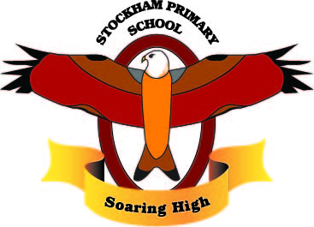
Theme/Subject: Shore is Fun!!

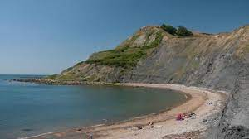Breadth:
As writers:  - Write legibly using appropriate joins.  - Plan, draft, edit, improve and proof-read our writing.  - Use paragraphs to organise our work.  - Use nouns, pronouns, conjunctions, adverbs, fronted adverbials, prepositions, possessive apostrophes and direct speech.  - Spell homophones and commonly misspelt words correctly.  - Use dictionaries to check the spelling and meaning of words.  Text: Hello Lighthouse by Sophie Blackall.  - Write an informal letter.  - Write a setting description.  - Write a newspaper report.  - Write a Tetractys poem. |  | As Athletes: Net and Wall Games  - Footwork.  - Aiming  - Racket Skills  - Skilful Hitting  - Rules of the Game  - Co-operating as a team | As Artists: Coastal Art and Alfred Wallis  - Draw in detail using black pen.  - Draw in oil pastel and colour pencil.  - Plan, design and make a printing tile.  - Create a seaside scene.  - Print onto my seaside scene. | As scientists: Forces and Magnets  - Identify forces acting on magnets.  - Movement over different surfaces.  - Sort magnetic and non-magnetic.  - Investigate the strength of magnets.  - Explore magnetic poles.  - Observe how magnets attract some materials.
As Readers:  - Read and listen to a wide range of styles of text.  - Listen to and discuss a wide range of texts.  - Use texts to infer, predict, explain, retrieve, summarise.  - Ask questions to improve understanding of a text.  - Retrieve and record information from non-fiction, using titles, headings, sub-headings and indexes. |  | As Mathematicians:  - Fractions- Count in tenths, fractions on a number line, fractions of a set of objects, equivalent fractions, compare and order fractions, add and subtract fractions.  - Recall and use multiplication and division facts for the 3, 4 and 8 multiplication table.  - Time- o’clock, half past, quarter past, quarter to, months and years, hours in a day, telling the time in 5 minutes, telling the time to the minutes, using am and pm, the 24 hour clock, finding durations, comparing durations, start and end times, measuring time in seconds. | As linguists (French):  - Meet my Family  - My Pets  - Alphabet  - What is his Name?  - How do you Spell? | As Musicians: The Dragon Song  - Listen and appraise the following pieces of music;  - The Dragon Song by Joanna Mangona and Pete Readman  - Birdsong - Chinese Folk Music  - Vaishnava Java - A Hindu Song  - A Turkish Traditional Tune  - Aitutaki Drum Dance from Polynesia  - Zebaidir Song from Sudan  - How to warm up vocally before singing.  - Compose with the song.  - Perform and share our songs.
As computer Experts:  - Develop sequential algorithms.  - Begin to use the de-bugging process.  - Use loops to more easily communicate instructions.  - Draw images by using simple loop instructions. |  | As Geographers: Coasts  - What is a coast?  - Draw and label the main physical features seen at a coast.  - Describe the words erosion and deposition.  - Which country in Europe has the longest coastline?  - What causes erosion?  - Describe the processes that create; Caves, bays, headlands, arches, stacks, cliffs, beaches.  - Define the term natural physical process.  - What is an artificial structure?  - Draw and label the following; Sea walls, rock armour, groynes.  - What are the advantages of each of the defences? | Religious Education: Islam  - Who and where  - Main Beliefs  - Special places  - Special festivals  - Holy Book  - Symbols and meanings | As citizens (PSHCE):  - Family Roles and Responsibilities  - Friendship  - Keeping Safe Online  - Being a global Citizen  - Celebrating my Web of Relationships
Key Vocabulary: | Coast, Erosion, deposition, beach, cliff, arch, stack, headland, bay, tourist destination, waves, caves, headland, natural physical process, artificial structures, advantage, disadvantage, sea walls, rock armour, groynes, prevent, promenade, boulder, maintain, observe, complete, force, contact, magnetic force, attract, repel, north (magnetic) pole, south (magnetic) pole.

Curriculum Drivers: | Curiosity: | Knowledge of the wider world: | Aspirations:
 | - What are coasts?  - Where are our nearest coasts?  - What do people do at the coast?  - Why do we have to control coastal erosion? | - How is a coast formed?  - What are the geographical features of a coast?  - How are coasts formed?  - Where is the longest coastline?  - What is erosion?  - What are the advantages and disadvantages of engineers trying to control natural processes?  - How are waves formed? | - What is the it like to be a coastal engineer?  - What other job opportunities are there by the coast?  - What would it be like to live by the coast?  - Which coasts would I like to visit and why?  - Could I be a scientist?

