[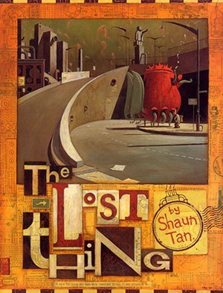](https://www.google.co.uk/url?sa=i&url=https%3A%2F%2Fwww.goodreads.com%2Fbook%2Fshow%2F69139.The_Lost_Thing&psig=AOvVaw2ZoDwNIUF5uS5iPumzGPji&ust=1591395244977000&source=images&cd=vfe&ved=0CAIQjRxqFwoTCKj_pLaX6ekCFQAAAAAdAAAAABAP)

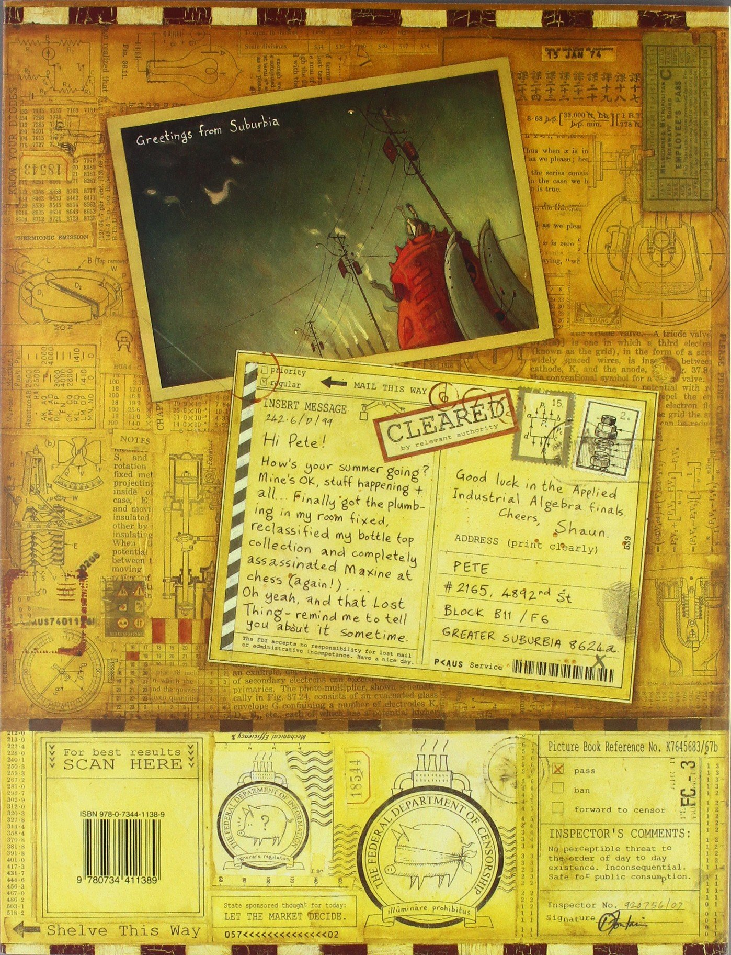

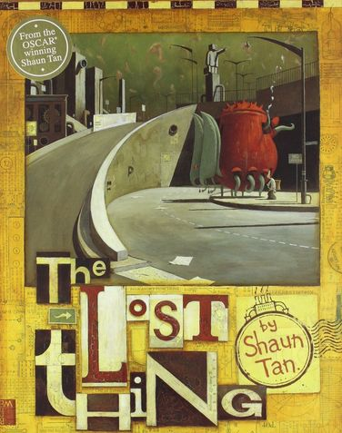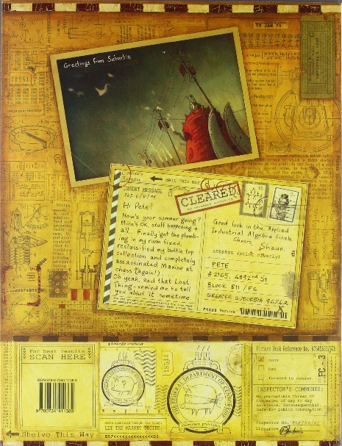

Infer– what can we infer from what we see?

_________________________________

_________________________________

_________________________________

_________________________________

_________________________________

_________________________________

_________________________________

Wonder– what questions do you have?

_________________________________

_________________________________

_________________________________

_________________________________

_________________________________

_________________________________

_________________________________

Observe—what can you see?

_________________________________

_________________________________

_________________________________

_________________________________

_________________________________

_________________________________

_________________________________

WALT– make predictions about a book