Theme:
All World’s A Stage
Term 6
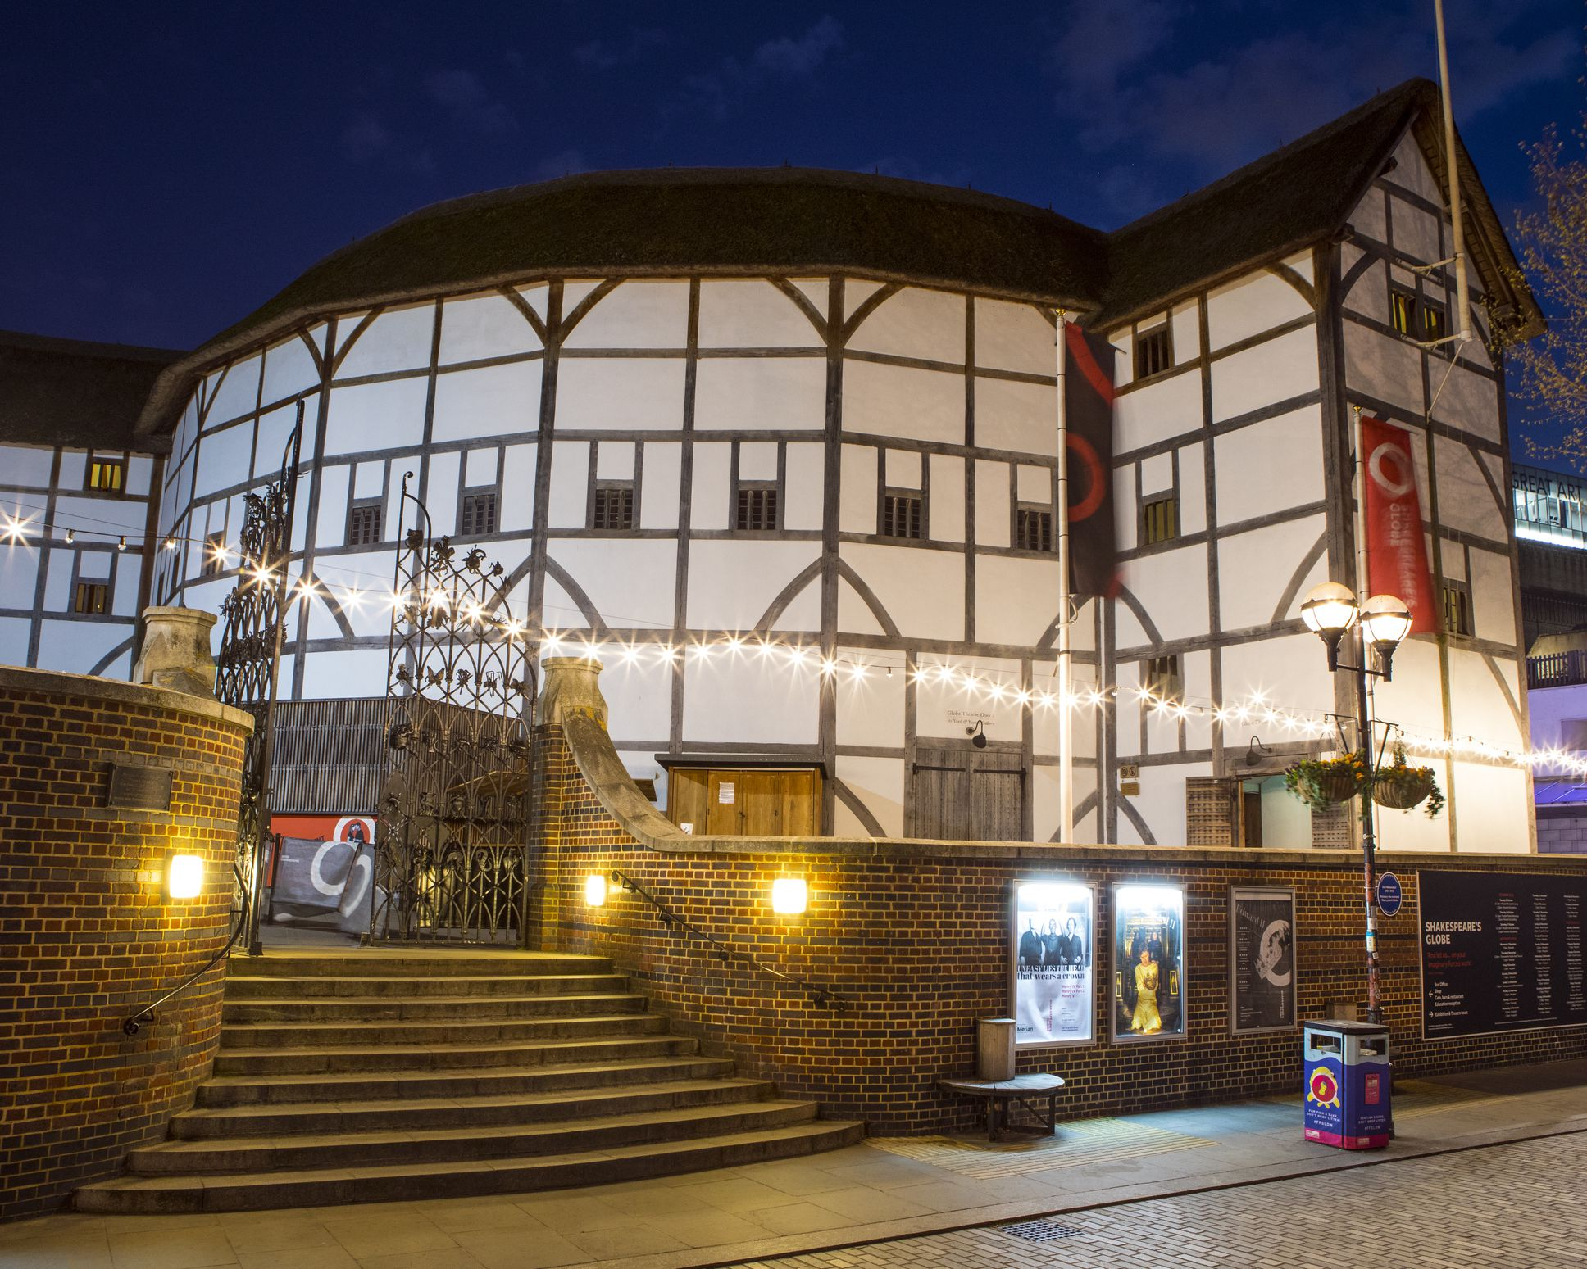
Home learning: | Reading for raffle prizes – 3 times a week minimum  Spellings homework  Homework choice grid - a minimum of 2 over the Term.

Lesson Breadth:
Being physically active:  Athletics  Choose the best place for running over a variety of distances.  Throw accurately and refine performance by analysing technique and body shape.  Show control in take off and landings when jumping.  Compete with others and keep track of personal best performances, setting targets for improvement  Problem solving–  Identify possible risks and ways to manage them, asking for and listening carefully to expert advice.  Embrace both leadership and team roles and gain the commitment and respect of a team.  Empathise with others and offer support without being asked. Seek support from the team and the experts.  Remain positive even in the most challenging circumstances, rallying others if need be.  Our PE days are: Monday and Tuesday |  | As musicians:  Sing or play from memory with confidence.  Perform solos or as part of an ensemble.  Sing or play expressively and in tune.  Sing a harmony part confidently and accurately.  Perform with controlled breathing (voice)  Create rhythmic patterns with an awareness of timbre and duration.  Convey the relationship between the lyrics and the melody.  Choose from a wide range of musical vocabulary to accurately describe and appraise music  listen with attention to detail and recall sounds with increasing aural memory  appreciate and understand a wide range of high-quality live and recorded music drawn from different traditions and from great composers and musicians | As designers:  Two day STEM visit – OAS – manufacturing technology centre (MTC) Abingdon.  Cut materials with precision and refine the finish with appropriate tools.  Show an understanding of the qualities of materials to choose appropriate tools to cut and shape.  Develop a range of practical skills to create products.  Convert rotary motion to linear using cams.  Design with the user in mind, motivated by the service a product will offer.  Make products through stages of prototypes, making continual refinements.  Ensure products have a high quality finish, using art skills where appropriate.  Use prototypes, cross-sectional diagrams and computer aided designs to represent designs. | As citizens (PSHCE):  I am aware of my own self-image and how my body image fits into that.  I can explain how girls’ and boys’ bodies change during puberty and understand the importance of looking after myself physically and emotionally.  I can describe how a baby develops from conception through the nine months of pregnancy, and how it is born.  I understand how being physically attracted to someone changes the nature of the relationship and what that might mean about having a girlfriend/ boyfriend.  I am aware of the importance of a positive self-esteem and what I can do to develop it.  I can identify what I am looking forward to and what worries me about the transition to secondary school /or moving to my next class.  I understand the different ways that people’s spending decisions can affect others and the environment, and that things have different values.
As readers:  Understand and explore the meaning of words in context.  Ask questions to improve understanding  Draw inferences.  Make predictions from what is stated and implied.  Summarise ideas.  Justify ideas  Participate in book talk.  Discuss and evaluate how writers use language, considering the impact on the reader.  Compare and contrast ideas accurately.  Texts: Various Shakespeare. |  | As computer Experts:  Explain why it is risky to share private information online.  Identify the reasons why people share information about themselves online  Choose what information about themselves is safe to share online.  Create an interactive computer program that expresses who they are with text and custom images.  Differentiate between commands that need to be repeated in loops and commands that should be used on their own.  Identify the benefits of using a loop structure instead of manual repetition.  Recognise the difference between using a loop and a nested loop | As writers:  Understand the power of comparison.  Perform compositions using appropriate tone, pitch and pace.  Understand and create rhyming couplets.  Create vivid images by using alliteration, similes, metaphors and personification.  Understand idioms and compound words and some of their origins with Shakespeare.  Texts:  Class reader: Shark Caller | As scientists:  Recognise that light appears to travel in straight lines.  Use the idea that light travels in straight lines to explain that objects are seen because they give out or reflect light into the eye.  Explain that we see things because light travels from light sources to our eyes or from light sources to objects and then to our eyes.  Use the idea that light travels in straight lines to explain why shadows have the same shape as the objects that cast them.
As historians  Derive the cultural, social and ethnic diversity of past society.  Give a broad overview of life in Britain from medieval until the Tudor and Stuarts times. |  | As Mathematicians:  Algebra  Ratio and proportion  Reasoning and problem solving | Religious Education:  Why do people go on pilgrimage? How can my life be seen as a journey?  Understand that life can be understood as a journey.  Learn about the commitment and sacrifice involved in pilgrimage.  Pupils should learn about the commitment to and experience of the Hajj for Muslims.  Learn about the importance of Pilgrimage for Christians, Jews and Muslims. | As linguists (French):
Key Vocabulary: | Loop, repeat, sonnet, idiom, compound word, legacy, translucent, transparent, opaque, waves, cornea, iris, pupil, lens, retina, optic nerve, reflection, refraction, spectrum, melody, harmony, pitch, rhythm.

Curriculum Drivers: | Curiosity: | Knowledge of the wider world: | Aspirations:
 | How will my body change over time? Why?  How am I able to see? | What was life like in the past? What did people do for entertainment?  Where does language use originate from? | How can I be the best I can be in secondary school?  What job opportunities are available to me? (STEM/creative arts etc)  Setting fun personal challenges and taking sensible risks.

