STOCKHAM PRIMARY SCHOOL
THURSDAY NEWSLETTER

Issue No: 539 Thursday 6th February 2020
Dear Parents and Carers,
Hero and Inspiration day
We have had a great day finding out about the people who inspire us. The children had some excellent ideas and were very articulate when sharing why they had chosen to dress up or represent their hero. Thank you for your donations towards the volunteer reading scheme.
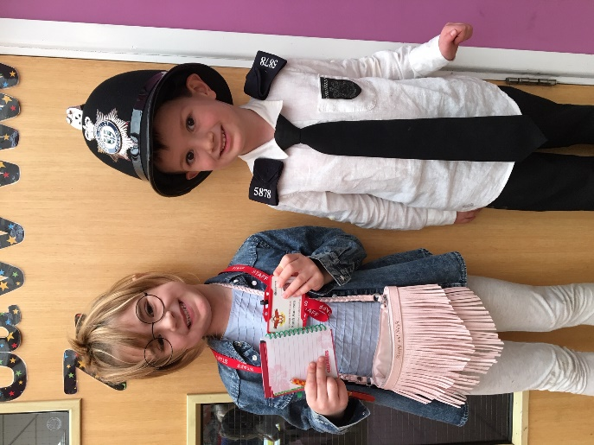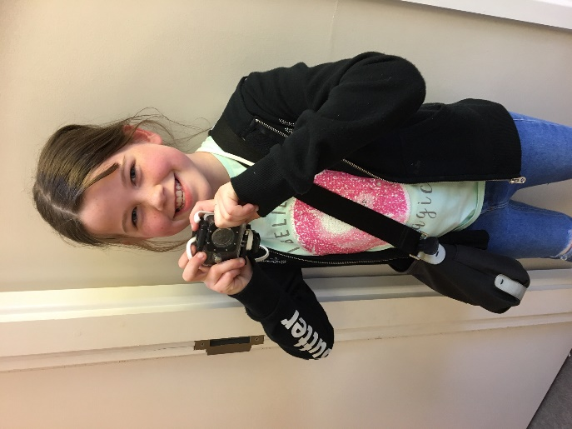
Eliza –Dressed as Mrs Anderson, Alistair dressed as his Daddy, Jessica dressed as Natalie Jezzard (A photographer and Mum - from our Aspirations day last year)

Additional dates for the diary
Weds 12th Feb @ 2.40pm - YEAR 4 assembly
Friday 14th February @ 3.05pm term ends.
Monday 24th February – Term 4 begins at 8.40am
Thursday 5th March –World Book Day –more information to follow
Week beginning 9th March – Parents evenings (Lists will be up after half term)
11th March – Foundation and Year 6 height and weight checks.
Thu 12th March @ 2.40pm - YEAR 5 assembly
Weds 18th March @ 2.40pm - YEAR 2 assembly
Weds 1st April @ 2.40pm - FOUNDATION assembly
Friday 3rd April – School finishes at 12.10pm.
Weds 29th April @ 2.40pm - YEAR 1 assembly
Reminder:
May Bank Holiday change – don’t forget that the original bank holiday Monday on 4th May has been moved to Friday 8th May.
Many thanks, Mrs. Burbank

PA’s this week were Ishani & Lucy-Jane. Thank you for your help.

CLASS NEWS

Year F In maths this week we have started to look at some of the teen numbers. We have
made the numbers using the Numicon. In literacy the children have been working
hard to get in the writers raffle by writing parts of The Gingerbread Man.
Year 1 In English Year 1 have been looking at information texts and what their features are.
In maths we have been learning to add by counting to 10 first.
Year 2 In Year 2 we have been continuing with our topic on The Great Fire of London and
combining this with learning about information texts. We followed instructions
carefully to make a miniature Tudor house from a template…..they look amazing!
Year 3 This week In maths we have been learning written methods of multiplication and
division. In English we have written narratives thinking carefully about the characters,
setting and plot. We have also been working hard for our assembly - we hope you
enjoyed it!
Year 4 Year 4 have been busy this week thinking about real life people we would like to write
letters to. We have been thinking about either a person or company we would like to
write a letter to and planning what we would like to ask them. We look forward to
sending them next week. In maths we have been learning about different methods
for multiplying larger numbers and applying our times tables facts.
Year 5 Year 5 have started learning about decimals in maths this week. In science we have
started a new topic all about forces. We have been painting pictures in the style of
David Hockney in our art lesson.
Year 6 This week, Year 6 have been busy writing up their short stories for the writing
competition. In maths they have been exploring area and perimeter word problems.
They were all brilliantly behaved on Monday when we visited the fire station to learn
numerous ways to stay safe.

Soaring High
This week the following children have earned “Soaring High”:
Year F Teddy for working really hard with his name writing. Well done Teddy! Clementine
for her fantastic story writing. She worked independently to write out the whole
story of The Gingerbread Man!
Year 1 Jasmine for always using such brilliant independence in her learning, well done,
you are always able to get on! Alfie W for using brilliant confidence in phonics, you
are always happy to answer questions, well done!
Year 2 Well done to Herbie for his hard work and great participation during carpet
sessions. Hard work and determination has paid off for Kathy and she is working
so well during her maths sessions discovering facts about the 2’s, 5’s and 10 times
tables.
Year 3 All of Year 3 for their fabulous assembly. Well done!
Year 4 Fabian for a very thoughtful and heartfelt explanation about his inspiration day
choice. He is clearly very inspired by his dad and all the other amazing NHS staff.
Milly for an amazing information page all about Chinese New Year. Milly put a lot
of effort into her work and it was beautifully presented.
Year 5 Isabella and Alex for careful editing of their reports in English. You made some
great improvements, well done!
Year 6 Jax for answering lots of questions at the fire station and showing great teamwork
helping others. Lucy E for being really determined with her learning all the time in
lessons and doing extra science work at home to learn more about the eye.

Well done everyone!

Tidy Tiger
This week Tidy Tiger goes to Year 2 for having the tidiest room. Well done!

Attendance Ted
Attendance Ted was awarded to Year 2 for having the best attendance last week, they will be looking after Attendance Ted next week. Well done!

School Uniform
If you need new uniform please order online or by telephone. The website is pmgschoolwear.co.uk and the order line is 0800 4046644.
Book bags and PE bags are also available to be purchased from pmgschoolwear.

