English  - Write legibly using appropriate joins.  - Use our 5 senses to describe.  - Plan, draft, edit, improve and proof-read our writing.  - Use paragraphs to organise our work.  - Use nouns, pronouns, conjunctions, adverbs, fronted adverbials, prepositions, possessive apostrophes and direct speech.  - Use dialogue in our writing.  - Write sentences for effect.  - Read our work aloud.  - Listen to and discuss a wide range of fiction, poetry, plays, non-fiction and reference books or textbooks.  - Understand the features of an explanation text.  - Write in complex sentences.  - Write our own explanation text. | Choco-licious!  Year 3  Term 1  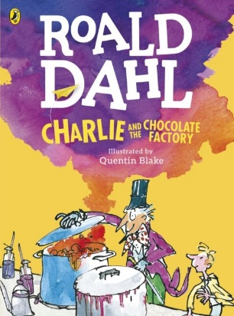  Text: Charlie and the Chocolate Factory. | Maths  - Place value within 1000.  - Comparing objects and numbers to 1000.  - Ordering numbers.  - Counting in 50’s.  - Adding and subtracting multiples of 100.  - Adding and Subtracting crossing 10’s.  - Adding and subtracting 2 and 3 digit numbers.  - Using inverse and estimating to check answers.  - Spotting patterns within our work.
PE: Gymnastics (Movement)

- Jumps and leaps.
- Rolls.
- Hand stands and cart wheels.
- Linking movements.
- Perform to whole class

French: Getting to know you
- Hello
- What’s your name?
- How are you?
- Goodbye
- Counting 1-10.
- How old are you?
Computing: Word Processing
- Typing.
- Symbols and saving.
- Editing.
- Undo and redo.
- Select and format.
- Formatting text.
Music  - Listen with attention to detail and recall sounds with increasing aural memory  - Appreciate and understand a wide range of high-quality live and recorded music drawn from different traditions and from great composers and musicians | History  - Explore the origins of the cocoa bean.  - Understand how the cocoa bean came to Europe.  - Explore the development of the Cadbury company. | Geography  - Understand where and how cocoa trees grow.  - The “journey of the cocoa bean.  - The life of a cocoa farmer.
PSHCE: Being in my World.  - Help others to feel welcome.  - Making our school a better place.  - Consider everyone’s right to learn.  - Caring about other’s feelings.  - Work well with others.  - Follow a learning charter. | Science: Super Scientists.  - Sir Isaac Newton  - Alexander Graham Bell  - Our senses and reflexes  - What makes us Ill?  - Thomas Edison | RE;What do we Know about Jesus?  - Understand representations of Jesus vary.  - Look at pictures of Jesus and interpret the different representations.  - Find out what Jesus was like and explore different people’s views of him.  - Explore symbolic language to describe Jesus.  - Explore our own response to Jesus.  .

Homework
Please choose an item a week from the homework menu that is in your homework book. Please also go on mathletics each week and also practise your spellings
Reading
Children are also expected to be reading at home at least 4 times a week;
please sign their Reading Journal to confirm this. Thank you!

Homework
Please choose an item a week from the homework menu that is in your homework book. Please also go on mathletics each week and also practise your spellings
Reading
Children are also expected to be reading at home at least 4 times a week;
please sign their Reading Journal to confirm this. Thank you!

Equipment and PE kit
As ever, your child will also need their book bag (with Reading Journal),
water bottle, plimsolls and PE kit (including trainers) in school every day.
Dates for Your Diaries
17th September – Trip to Cadbury World.

