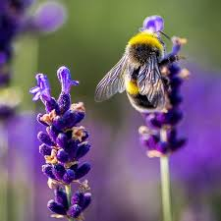
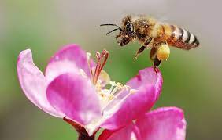
Topic
Buzzy Bees
Breadth:
As writers:  Looking at wild life poetry and writing our own nature poems.  We will be labelling diagrams of flowers and insects.  Learning Phase 5 Phonics and using it in our writing  Texts:  Poems: Nut tree by Julia Donaldson  What do you do on a Nature Walk? By Kate Williams |  | Being physically active:  We will be participating in team games and learning about different athletic games.  Our PE days are: Wednesday but there may be opportunities for additional sports during the week. Please ensure your child has a PE in school all week. | As readers:  We will be listening to and reading a wide range of text styles including poetry.  Using text to find information about flowers and insects.  Asking and answering questions to help develop a stronger understanding of a piece of text. | As Mathematicians:  We will be counting forwards and backwards within 50  Learning to recognise and use symbols for Multiplication and division.  Making doubles and finding halves.  Making equal groups to share  Counting in 2s, 5s and 10s  Learning about weight, mass, capacity and volume.
As Artists:  Spotlight artist ‘Georgia O’Keeffe’  We are exploring Georgia O’Keeffe’s techniques and how she expresses her emotions and feelings through her art work. We will be exploring our own feeling through charcoal sketches. |  | As Scientists  Observing closely, identifying and classifying different flowers and plants.  Describing how pants need water, light and a suitable temperature to grow. | As citizens (PSHCE):  Relationships!  We will be thinking about our families and how there are lots of different types of families.  Identifying what makes a good friend. | As musicians:  We are learning about the different music styles.  Finding the pulse and clapping to the beat.  Listen and appraise a piece of music.
As computer Experts:  Learning how to complete a piece of simple code on Code.org using looping of simple sequences of instructions.  Building upon our knowledge of letter placements on a keyboard. |  |  | Religious Education:  Why is Easter a time of celebration for Christians?  We will be looking for signs of spring and thinking how growth and new life fits into Easter.
Key Vocabulary: | English: Nouns, proper nouns, adjectives, stanza, rhyming couplets,  Art: pioneer, charcoal, tactile, sketching=, techniques |  | Maths: multiplication, division, equal groups, mass, capacity, volume, scales, balance  Science: evergreen, deciduous, bulbs, seeds, roots, invertebrates, environment

Curriculum Drivers: | Curiosity: | Knowledge of the wider world: | Aspirations:
 | What do Bees do? How does a plant grow?  Do I like honey? Can I taste the difference between local and shop brought honey? | Exploring the beauty of our local surroundings, looking at wildlife and flowers. Identifying and naming British plants and trees. | How can I help the environment?  Could I be a bee keeper?  Can I be a poet? Who is Georgia O’Keeffe? Can I be an artist?

Home learning: | Will go out every Thursday and needs to be back in on a Tuesday. Please continue reading at home with your child at least three times a week.

