STOCKHAM PRIMARY SCHOOL
THURSDAY NEWSLETTER

Issue No: 434 Thursday 16th March 2017
Dear Parents,
This week we have been enjoying British Science week. There have been some excellent learning activities across the school. Mrs McNaught is our science co-ordinator and will tell you more about what the children have been doing. Thank you for organising these opportunities Mrs McNaught!
We are all getting very excited about our Red Nose day talent show. The children have been rehearsing in school and sharing their talents within their classrooms. Tomorrow is audition day. I am very excited and have a feeling I am going to be blown away by some singing and acts. Please can you support your child by helping them to bring in any costumes, props or music that they might need in order to do their best performance. If we manage to see all 52 acts in the afternoon, the children will know if they are through. On the 24th March we will be having the final in the afternoon. Children do not need to wear school uniform on this day. They may choose to dress in red, come dressed back to front or have a silly hair day. Please make a generous donation on this day so that we can raise lots of money for comic relief.
Year 6 will be enjoying a trip to watch the dress rehearsal of King Alfred's children performing 'Joseph' next Tuesday. All information regarding packed lunches and changed home time has been sent to Year 6 parents.
Have a lovely weekend.
Thank you,
Mrs Burbank.

PAs this week were Freya and Kyra. Thank you for your help.

BRITISH SCIENCE WEEK
This week we have been participating in British Science Week and the children have been enjoying a wide variety of scientific activities to excite and inspire them. We were delighted to welcome the STEM ambassador David Hawkins into school on Wednesday to teach us about how rockets work, and to launch homemade rockets from the playground! Today we enjoyed a talk from the real life Bat Man David Endacott from the Bat Conservation Trust. We were fascinated by the bats he brought along with him! On Tuesday, Sylvia Ward and Jenny Bahar organised a treasure hunt for our Eco Reps, where they found out some amazing facts about waste and recycling. On Friday we have some of our parents and governors sharing their expertise with the children. Thank you to Claire Terry, Heena Brown and Debbie Poole for giving up their time to teach us about materials, gearboxes and DNA extraction!
Each class has also enjoyed/ will be enjoying a Science morning within their keystage where the teachers have planned activities such as raft building, making slime and lava lamps, investigating the human senses, echolocation, a squashed tomato challenge, exploring magic beans and how to protect the Giant's golden eggs!
Please ask your child to find out more ...

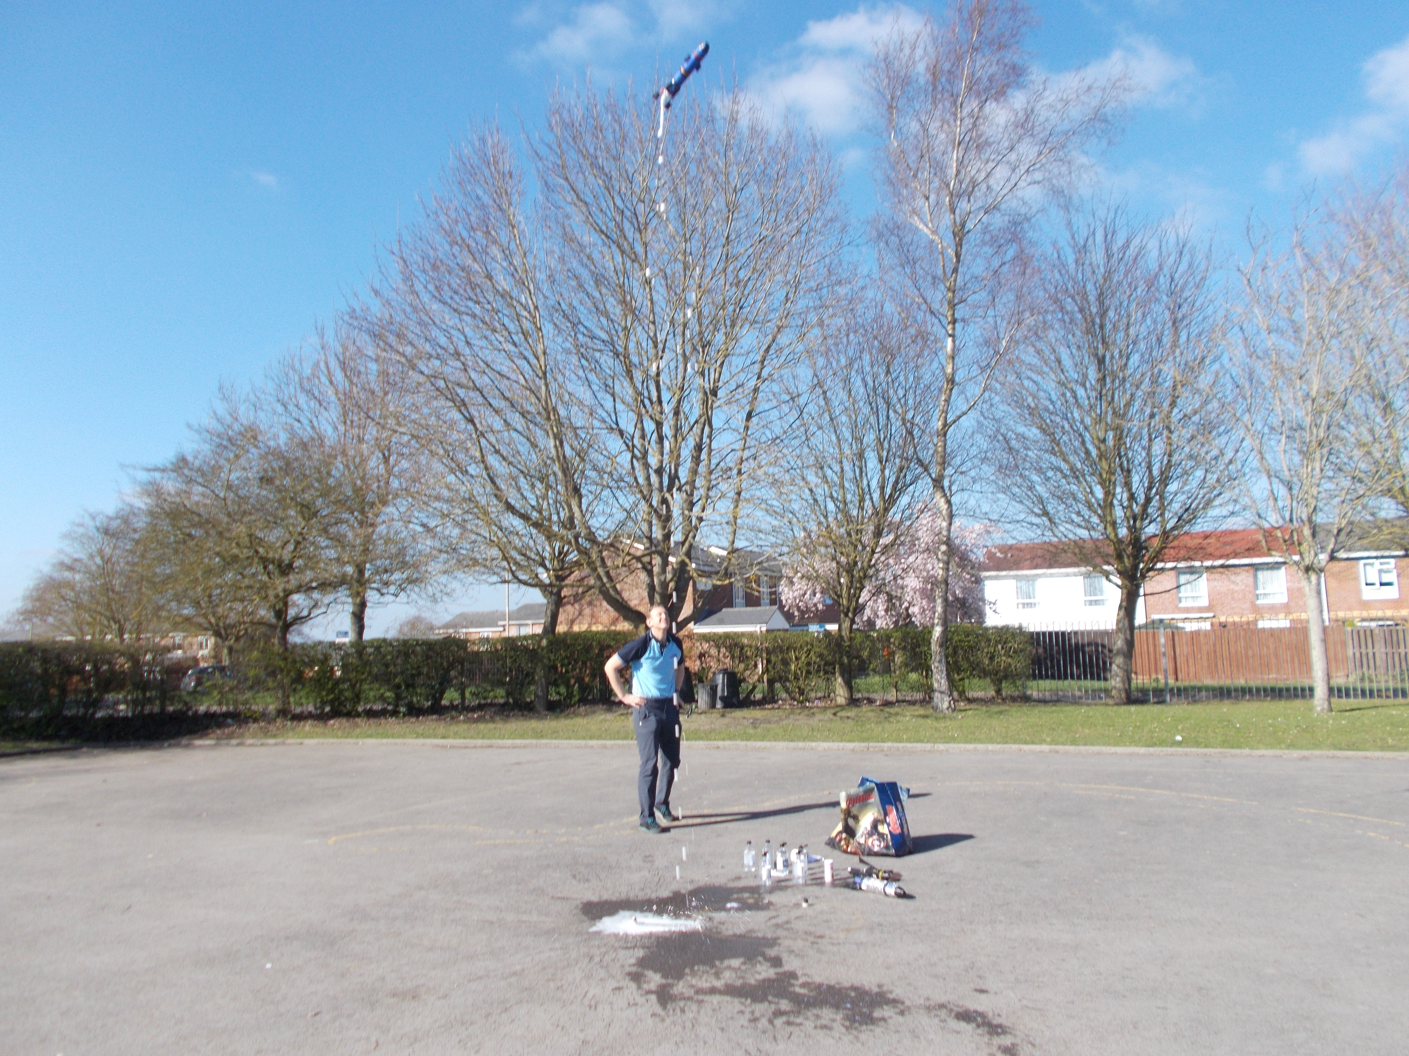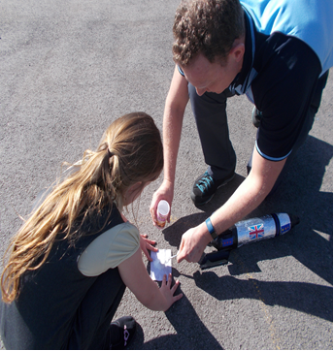

School Dinners
The menus for the next 3 week cycle have been given to the children. Please fill this out and return to school by Friday. This is important for the kitchen staff to place their weekly food order.

Forest School
This week at Forest School we used our Teamwork skills to empty the soil out of the bath. We tried to move it on log rollers (like our Stone Age ancestors) but ended up carrying it (again, like our ancestors might have done!) We will re-use it in our Forest School area.
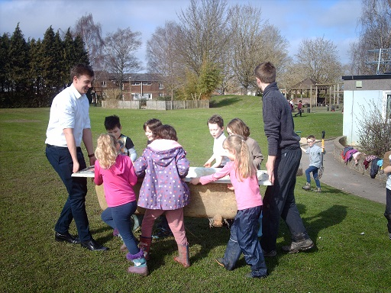

CLASS NEWS

Year F This week we have been learning about Jack and the Beanstalk. We have planted
beans. We wrote about what we would grow if we had our own special magic
beans. In maths we have been ordering numbers to 10 and 20.
Year 1 In our topic lessons we have been comparing our daily lives to those of our
parents and grandparents. In English we have been working on settings for
traditional tales.
Year 2 In English we have written spring poems and in maths we have been looking at
2D & 3D shapes and lines of symmetry.
Year 3 In English we have been writing explanation texts and starting to look at our new
text “The Day the Crayons Quit”! In maths we have been looking at division.
Year 4 This week we have been enjoying taking part in activities for Science Week. On Monday we made slime and lava lamps! We have also been learning a song about the Romans in music.
Year 5 This week in Year 5 we have been planning an alternative ending to Beowulf; we have designed our own Norse monsters. We have also learnt to tackle safely in our hockey lessons!
Year 6 This week Year 6 have been looking at algebra and writing descriptions. In
science we have made electronic board games.

Soaring High
This week the following children have earned “Soaring High”:
Year F Ella for super confidence with ordering numbers to 20. Alandria for creating a
great picture of the giant from Jack and the Beanstalk, using the laptop.
Year 1 Kiran for always setting a good example in the classroom and for persevering
with independent work. Amber for always being incredibly helpful and for
cheering everyone up with her happy nature!
Year 2 Omar for great confidence and pride performing his dance in PE. Freddie for
persevering with his maths and really impressing Jenny!
Year 3 Mia for showing great pride when writing her spring poem. Ishani for always
showing great determination and perseverance at school!
Year 4 Nicole for writing some great sentences in her story about Pompeii.
Rory for trying really hard to join his handwriting in all his work.
Year 5 Jake G for producing an excellent, detailed description of his Norse monster.
Alfie for really trying hard in PE; after missing the first three lessons due to his
broken arm, he showed great determination to understand.
Year 6 All of the netball team for playing brilliantly. Well done!

Well done everyone!

Tidy Tiger
This week Tidy Tiger goes to Year 6 for having the tidiest room. Well done!

Attendance Ted
Attendance Ted was awarded to Year 6 for having the best attendance last week, they will be looking after Attendance Ted next week. Well done 6 Year!

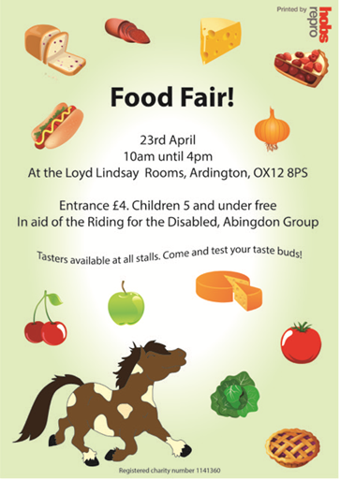
School Uniform
If you need new uniform please order online or by telephone. The website is pmgschoolwear.co.uk and the order line is 0800 4046644.
Book bags and PE bags are also available to be purchased from pmgschoolwear.

