English  - Write legibly using appropriate joins.  - Plan, draft, edit, improve and proof-read our writing.  - Use paragraphs to organise our work.  - Use nouns, pronouns, conjunctions, adverbs, fronted adverbials, prepositions, possessive apostrophes and direct speech.  - Spell homophones and commonly misspelt words correctly.  - Read our work aloud.  - Listening to and discussing a wide range of fiction, poetry, plays, non-fiction and reference books or textbooks.  - Read and understand root words, prefixes, suffixes and exception words.  - Use dictionaries to check the spelling and meaning of words.  - Write our own Adventure Story.  - Create a holiday brochure for Skara Brae. | The Savage Stone Age!  Year 3  Term 2  Text: Stone Age Boy  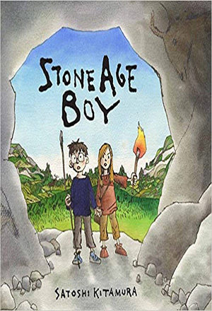 | Maths  - Count from 0 in multiples of 4, 8, 50 and 100; find 10 or 100 more or less than a given number.  - Add and subtract numbers mentally, including: a three-digit number and ones; a three-digit number and tens; a three digit number and hundreds.  - Add and subtract numbers with up to three digits, using formal written methods of columnar addition and subtraction.  - Estimate the answer to a calculation and use inverse operations to check answers.  - Recall and use multiplication and division facts for the 3, 4 and 8 multiplication table.  - Write and calculate mathematical statements for multiplication and division using the multiplication tables that they know, including for two-digit numbers times one-digit numbers, using mental and progressing to formal written method.
PE: Circuit Training
- Ways to travel
- Changing Travel
- Ball Skills
- Balance and Coordination
- The Full Circuit
- Adapt and Improve
French: Time
- Counting 11-31
- Days of the week
- Months of the year
- Mon Anniversaire
- What’s the date today?
- Yesterday, Today, Tomorrow

Art/DT  - Prehistoric Art  - Cave Paintings  - Stone Age Jewllery  - Stone Age Art |  | Computing: Using the Internet  - Word Order  - Order of Returned Results  - Saving and Sharing  - How do we Communicate Online  - Word Order
Music  - Listen with attention to detail and recall sounds with increasing aural memory  - Appreciate and understand a wide range of high-quality live and recorded music drawn from different traditions and from great composers and musicians | History  - What is Prehistory?  - Stone Age People  - Star Carr  - Stone Henge  - The Bronze Age  - The Iron Age  - Stone Age to Iron Age facts | Science – Rocks, Fossils and Soil  - Natural Rocks  - Grouping Rocks  - Erosion and Permeability  - Useful Rocks  - Exploring Soils  - Fossil Formation  - Identifying Fossils
PSHCE: Celebrating Difference .  - Families  - Family Conflict  - Witness and Feelings  - Witness and Solutions  - Word that Harm  - Compliments | 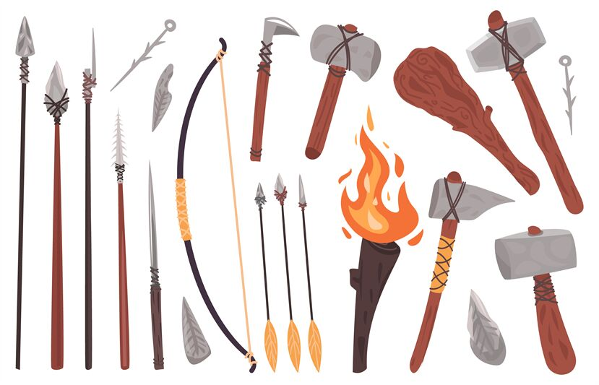 | RE; Jewish Celebrations  - Passover  - Sukkot  - Purim  - Hanukkah  - Rosh Hashanah

Homework
Please choose an item a week from the homework menu that is in your homework book. Please also go on mathletics, TT Rock Stars and Spelling Shed whenever you are able to.
Reading
Children are also expected to be reading at home at least 4 times a week;
please sign their Reading Journal to confirm this. Thank you!

