English  - Write legibly using appropriate joins.  - In narrative, create settings, characters and plot.  - Plan, draft, edit, improve and proof-read our writing.  - Use paragraphs to organise our work.  - Use nouns, pronouns, conjunctions, adverbs, fronted adverbials, prepositions, possessive apostrophes and direct speech.  - Spell homophones and commonly misspelt words correctly.  - Read our work aloud.  - Listen to and discuss a wide range of fiction, poetry, plays, non-fiction and reference books or textbooks.  - Read and understand root words, prefixes, suffixes and exception words.  - Use dictionaries to check the spelling and meaning of words. | Year 3 Term 6  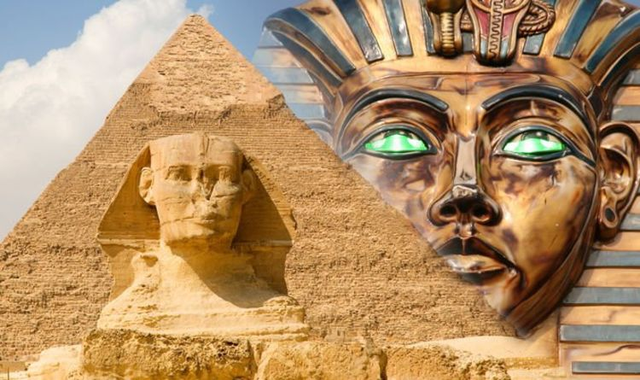  Ancient Egypt | Maths  - Revision of previous topics  - Active Maths  - Times tables torture!
Science
- Identify and describe the functions of different parts of flowering plants: roots, stem/trunk, leaves and flowers explore the requirements of plants for life and growth (air, light, water, nutrients from soil, and room to grow) and how they vary from plant to plant
- Investigate the way in which water is transported within plants
- Explore the part that flowers play in the life cycle of flowering plants, including pollination, seed formation and seed dispersal.
PE: Athletics & Team Games  - Use running, jumping, throwing and catching in isolation and in combination  - Play competitive games and apply basic principles suitable for attacking and defending  - Develop flexibility, strength, technique, control and balance | History: Ancient Egypt  - Learn about when and where the first civilisations appeared and the achievements of the earliest civilizations. | Computing: Internet Safety  - Use technology safely, respectfully and responsibly; recognise acceptable/unacceptable behaviour; identify a range of ways to report concerns about content and contact.
DT  - Design, make and evaluate a variety of objects using a range of tools and skills.  - Learn about the seasonality of some food products. | PSHCE: Going for Goals!  - Use my strengths as a learner.  - Know that I am responsible for my own learning and behaviour.  - Break down a goal into a number of steps and wait for the result  - Recognise when I find learning difficult and persevere when I need to.  - Take responsibility for my actions and learning when the outcomes are positive or negative. | Music  - Play and perform in solo and ensemble contexts, using their voices and playing musical instruments with increasing accuracy, fluency, control and expression.
Art  - Improve their mastery of art and design techniques, including drawing, painting and sculpture with a range of materials. |  | French: Ma Famille  - Join in, speak, listen and respond.

Homework
This term’s homework is a project to be completed at home and handed in on Monday 1st July
(please see separate letter).

Reading
Children should also continue to read at home at least 3 times a week; please sign their Reading Journal to
confirm this.

Equipment and PE kit
(All items clearly named, please!)
As ever, your child will also need their book bag (with Reading Journal), water bottle, plimsolls and PE kit
in school every day. Please also ensure your child is wearing sun cream and has a sunhat in school.
We shall be doing PE outside as much as possible, so children will need a pair of trainers
in school this term. Your child will also need a plain t-shirt in their house colour for Sports Day
and other competitive events.

Dates For Your Diary
Wednesdays 5/6, 12/6, 19/6, 26/6 and 17/7 Group B Forest School (NB: NO FOREST SCHOOL 3/7 and 10/7)
Friday 21st & Monday 24th June INSET days (School closed to children)
Wednesday 26th June 2:40pm Year 3 Assembly
Monday 1st July Homework projects due in
Thursday 4th July Class Swap afternoon (Year 3 to Year 4!)
Wednesday 10th July Sports Day (KS2 pm)
Wednesday 24th July 12:10pm End of term

Thank you for your continued support,
please do not hesitate to contact me if there is any further information you require.

