**My I Spy Scavenger Hunt**

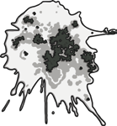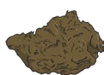

|  |  |  |  |
| --- | --- | --- | --- |
| smooth Leaf | spiky leaf | twigs on  the ground | rocks |
| soil | smooth bark | rough bark | nuts or seeds |
| fruit or berries | red flowers | yellow flowers | white flowers |
| flying insect | ants | caterpillar | butterfly |
| spider | web | snail | nest |
| feather | bird flying | footprints | animal droppings |



**visit twinkl.com**