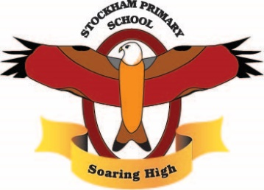

Curriculum Long Term Plan 2021-22
 | Autumn Term | Spring Term | Summer Term
Whole School Theme |  | Winter Olympics | Monarch
Values  Cycle 1 | Kindness  Friendship  Celebrating differences  Humility | Goals and ambitions  Confidence  Healthy me, healthy mind | Trust  Self-belief and Courage
Learning skills | -Independence – Confidence – Listening – Teamwork  - Perseverance
Curriculum drivers | Aspirations – Who could I be? How can I aim high? How can I make the most of my opportunities? What opportunities are out there for me?  Curiosity – What do I think? What do I wonder? Why?  Knowledge of the world – Who am I? What is my locality? How does my life compare to the wider world? How do I fit in to the wider world? How can I take responsibility for both my community and the wider world?
EYFS | Marvellous me  Witches kitchen  Light festivals | Winter  Once upon a time  Eggs | Pirates  Under the sea
Year 1 | Marvellous me  Gunpowder plot  Room on a broom | Once upon a time  Buzzy bees | Queen of hearts  Australia
Year 2 | Victorians  Incredible India | Fire fire  It’s a kind of magic | Countries of the UK  Rumble in the jungle
Year 3 | Chocolicious  Stone age-iron age | Ancient Egyptians  Good to be me | Divorced, beheaded, died  From field to fork
Year 4 | Rivers  Romans | Shanghi Dynasty | Inventions
Year 5 | South America  Space Race | Anglo Saxons  Local study | Ancient Greece  Biomes
Year 6 | Resilient Me  Frozen North  No Planet B | The power of words.  Winter Olympics  Marvellous Medicine | Terrific Tudors  Ancient Explorers  All the world’s a stage
Special Whole School Events | Anti-bullying Week | Winter Olympics  World Book Day  Safer Internet Day | 50 Years of Stockham  Platinum Jubilee  RSPCA week

‘Soaring High’

