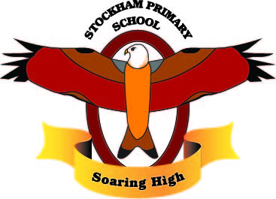
Year 3 Term 3: Ancient Egypt

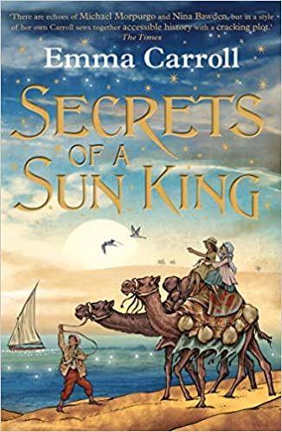

As writers: Dairy Entry, Biography and poetry,  Spell homophones and commonly misspelt words correctly.  Use similes, metaphors and adjectives to describe our thoughts and feelings and to add to detail to our writing.  Use powerful verbs.  Plan, draft, edit, improve and proof-read our writing. |  | As Athletes:  Egyptian Dance  Refine movements into sequences. Create dances and movements that convey a definite idea.  Change speed and levels within a performance.  Develop physical strength and suppleness by practising moves and stretching. | As design technologists:  Baking Bread.  Make a Shaduf.  As artists:  Papyrus Painting  Cartouches | As scientists:  Recognise that we need light in order to see.  Understand dark is the absence of light.  Notice that light is reflected from surfaces.  Recognise that light from the sun is dangerous and that there are ways to protect our eyes.  Recognise that shadows are formed when the light from a light source is blocked by a solid object.  Find patterns in the way that the size of the shadow changes.
As readers:  Read and listen to a wide range of styles of text.  Listen to and discuss a wide range of texts.  Learn a wide range of poetry by heart  Use texts to infer, predict, explain, retrieve, summarise. |  | As Mathematicians:  Recall and use multiplication and division facts for the 3, 4 and 8 multiplication table.  Write and calculate mathematical statements for multiplication and division.  Measurement:Add and subtract amounts of money to give change. | As linguists (French):  My School  What is in the Classroom?  What is in my pencil case?  School subjects.  PE Lessons. | As musicians:  Listen with attention to detail and recall sounds with increasing aural memory.  Appreciate and understand a wide range of high-quality live and recorded music drawn from different traditions and from great composers and musicians.
As computer Experts:  Explore Internet Safety  What is Cyberbullying?  Emailing.  Safe Online Communication.  Keeping our information safe. |  | As Historians:  Label a timeline.  Describe social society.  Describe the characteristic features of the past relating to ideas, experiences attitudes and beliefs of men, woman and children.  Use evidence to ask questions and find answers to questions from the past. | Religious Education:  The Israelites in Ancient Egypt  Jacob’s Family Tree.  Jacob’s Favourite.  Pharaoh’s Dreams.  A Family Reunion.  Living in Egypt. | As citizens (PSHCE):  Dreams and Goals  What are Dreams and Goals?  My Dreams and Ambitions.  A New Challenge.  Celebrating my Learning.
Key Vocabulary: | Archeologist, influential, decipher, canopic jars, sarcophagus, mummy, mummification, hieroglyphics, temples, engineering, architects, commemorate, achievements, afterlife, preserve, essential, embalmed, eternity, pharaoh, papyrus, curses, scribing, tombs, pyramids, pharaohs, afterlife.

Curriculum Drivers: | Curiosity: | Knowledge of the wider world: | Aspirations:
 | What was life like in the Ancient Egyptian times?  Who was Tutankhamun and what is he well known for?  Who was Cleopatra and what was she like as a person?  How have the Ancient Egyptians shaped life today? | How do we appropriately use the internet?  What do I do if I am concerned about the use of the internet?  How has life changed now compared to that in Ancient Egypt?  What is life like for people in other countries? | Reference to archaeologists and their key discoveries for Ancient Egypt.  What are my dreams and goals for both the near and longer future?

