**Maths**

Number- place value

Count in multiples of 6, 7, 9. 25 and 1000.

Recognise the place value of each digit in a four digit number

Order and compare numbers beyond 1000

Round any number to the nearest 10, 100 or 1000

Count backwards through zero to include negative numbers.

**Science: States of Matter**

Describe the properties of solids, liquids and gases

Explain what happens to states of matter when the temperature changes

Explain the process of condensation and evaporation

Describe the water cycle

**English**

Fiction – Stories from other worlds – “Mouse, Bird, Snake, Wolf.”

SPAG (Spelling, Punctuation and Grammar) – pronouns and apostrophes.

**Geography**

Locate key rivers in the U.K and other countries.

Explain how a river is formed.

Describe the different parts of a river.

Describe different ways in which rivers and used.

**ICT**

We are software developers – developing a simple educational game.

Term 1 - Rivers and the Water Cycle

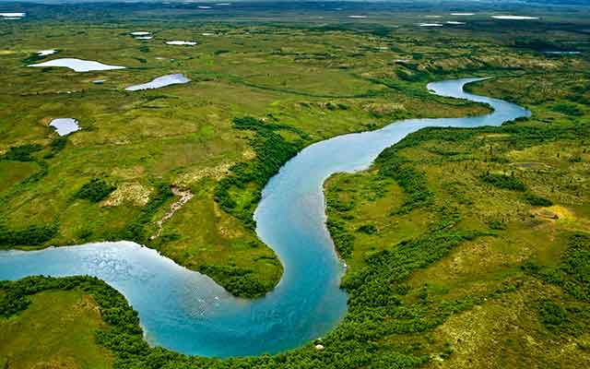

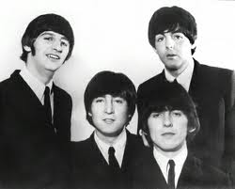

**Music**

Recorders and Music Express.

**Homework**

Set every Wednesday to be handed in the following Tuesday morning, English – spellings (approx.20 mins) and Maths (approx.20mins) are set weekly. In addition to set homework, children should spend 20 minutes reading 3 days a week. They will then be entered into our weekly Reading raffle!

**PE**

Invasion games - Hockey

Gymnastics - Balance

**RE: What is my view of the Bible?**

Why is the Bible a special book for Christians?

How is the Bible divided?

How do Christians use the Bible?

How does the Bible influence a Christian’s life?

**PSHE & SEAL: New Beginnings**

Devise class rules

Understand Stockham’s ‘Learning Powers’.

Recognise your gifts and talents and those of others.

**French**

Greetings