**I am a scientist…**

**States of Matter**

* Describe the properties of solids, liquids and gases
* Explain what happens to states of matter when the temperature changes
* Explain the process of condensation and evaporation.
* Describe and understand the water cycle.

**I am a mathematician….**

**Number- place value**

* Partitioning
* 100 more or less
* 1000 more or less
* Numberlines
* Counting in 1000s and 25s
* Comparing numbers
* Ordering numbers
* Rounding to the nearest 10, 100 and 1000
* Negative numbers
* **Addition and subtraction**
* Adding and subtracting 1s, 10s, 100s and 1000s

**I am a writer…**

**Fiction –** Traditional tales – Writing to entertain “How the Frog Came to be the King of the Rivers and Marshes” – following the story telling structure, including innovating own version.

**Poetry –** Writing to entertain – The River

**SPAG** (Spelling, Punctuation and Grammar) – pronouns and apostrophes. Year 3/4 word list.

Weekly spelling patterns.

**ICT**

* We are software developers – developing a simple educational game.

**I am a geographer….**

* Locate key rivers in the U.K and the world.
* Explain how a river is formed.
* Describe the different parts of a river.
* Describe different ways in which rivers are used.
* Identify and describe the different features of a river.
* Explore flooding and the use of dams.
* Explore the local river system- inc chalk streams.

**Homework**

**See homework menu grid**

* Spellings are set weekly, given based on the Year 3/4 list or spelling pattern. Children to practise using Spelling Shed.
* Children to practise times tables facts using Times Tables Rockstars.
* Choice of activity from the homework menu- one per week, all to be handed in at the end of term.
* Children should also spend 20 minutes reading, 3 days a week. **Reading diaries will be checked on a Tuesday and should be in school every day.**

Year 4 Ter m 1 –

By the Riverbank



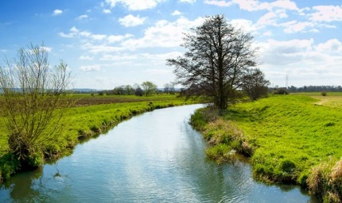

**I am a musician….**

* Appreciation of different pieces of water.

**I am an artist…**

* Colour study of river scenes – coloured pencil and watercolours.
* Study of artists who create work based on water.
* Pointillism study and river study artwork.

**I am a designer.**

* Creating models of the water course.

**PSHE & SEAL: New Beginnings**

* Devise class rules
* Understand Stockham’s ‘Learning Powers’.
* Resilient Me