**Maths**

Addition and subtraction up to 4 digits

Estimating and using the inverse

Solve addition and subtraction two step problems

Finding the perimeter of rectilinear shapes.

Convert between different units of measure

**Science: Digestive System and Teeth**

Describe the functions of the basic parts of the human digestive system

Describe the different types of teeth in humans

Explain the functions of different types of teeth

**English**

Fiction – Narrative – film unit – “So Good To Me.”

Poetry – Syllabic Form – winter poems

SPAG (Spelling, Punctuation and Grammar) –apostrophes and conjunctions.

**Geography**

Describe the different parts of a river.

Identify and describe the different features of a river.

Describe different ways in which rivers and used.

Explore flooding and the use of dams.

Bridges and water wheels – link to D.T

**Art**

Monet – artist study

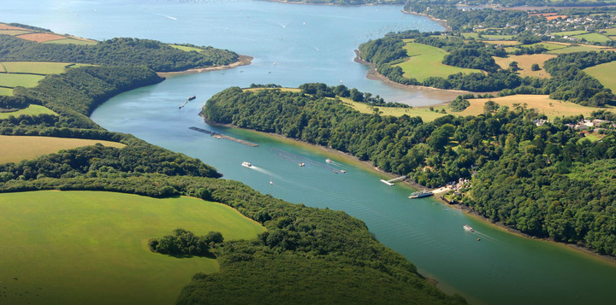

Term 2 - Rivers



**Music**

Recorders and Music Express.

**Homework**

Set every Wednesday to be handed in the following Tuesday morning, English – spellings (approx.20 mins) and Maths (approx.20mins) are set weekly. In addition to set homework, children should spend 20 minutes reading 3 days a week. They will then be entered into our weekly Reading raffle!

**PE**

Disability Sports

Dance linked to topic

**RE: Does art express religious beliefs and ideas?**

To reflect on a range of images that portray Jesus.

To describe how artists’ beliefs and backgrounds have influenced their work.

Ask and suggest answers to questions.

**PSHE & SEAL: Growth Mindset**

Describe what a growth mindset is.

Explain how perseverance shows a growth mindset

Describe the difference between a growth and fixed mindset

**French**

Days of the week.